I'm Yours
Date | 2022-02-07 09:33:07

SOLD OUT
We are pleased to announce this year's Valentine's Day edition print by Mr. Brainwash, I'm Yours.
This hand-finished edition collection will include 3 design variations using different slogans, each with 3 color variations (Red/Blue/Pink). Each variant will be released on Archival Paper as an Edition of 20 plus 3 AP, as well as Framed Canvas as an edition of 3.
SOLD OUT
We are pleased to announce this year's Valentine's Day edition print by Mr. Brainwash, I'm Yours.
This hand-finished edition collection will include 3 design variations using different slogans, each with 3 color variations (Red/Blue/Pink). Each variant will be released on Archival Paper as an Edition of 20 plus 3 AP, as well as Framed Canvas as an edition of 3.
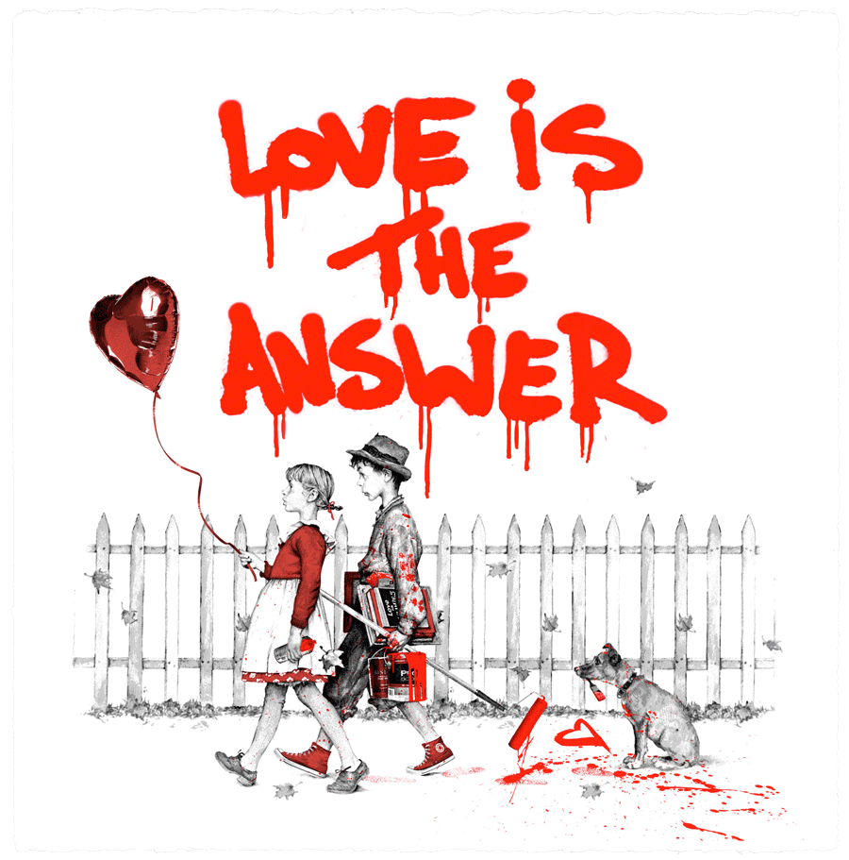
I'm Yours - Love Is The Answer
Archival Paper with Deckled Edges
22 x 22 in.
Available in 3 Colors (Red, Blue, Pink)
6-Color Screenprint with 1 Hand-Finished Stencil Layer
Edition of 20
AP Edition of 3
Certificate of Authenticity
Signed and thumb printed by the Artist
$800.00 / $1,600.00 (AP)
SOLD OUT
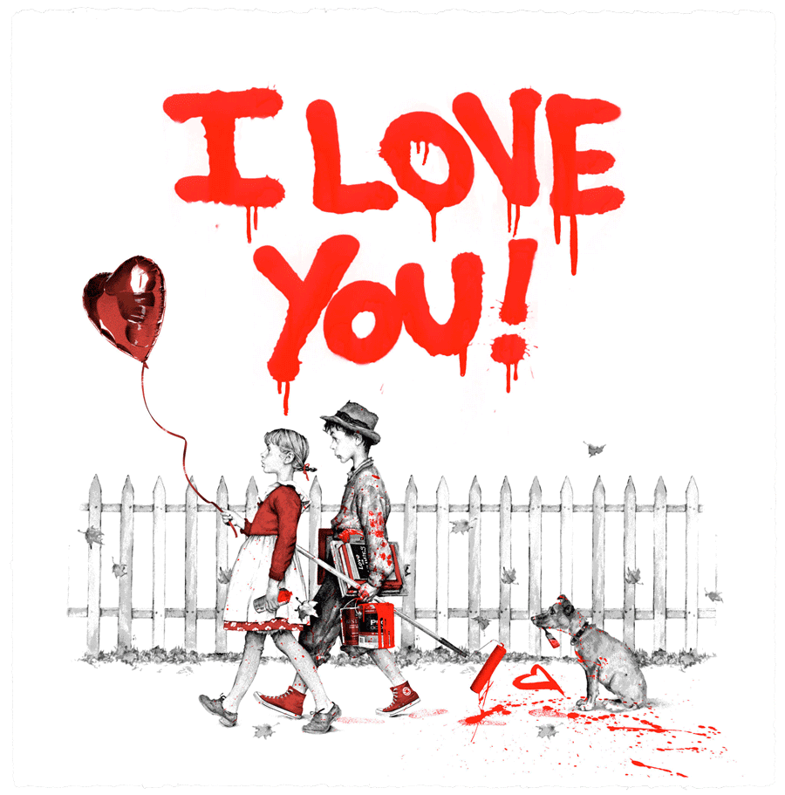
I'm Yours - I Love You
Archival Paper with Deckled Edges
22 x 22 in.
Available in 3 Colors (Red, Blue, Pink)
6-Color Screenprint with 1 Hand-Finished Stencil Layer
Edition of 20
AP Edition of 3
Certificate of Authenticity
Signed and thumb printed by the Artist
$800.00 / $1,600.00 (AP)
SOLD OUT
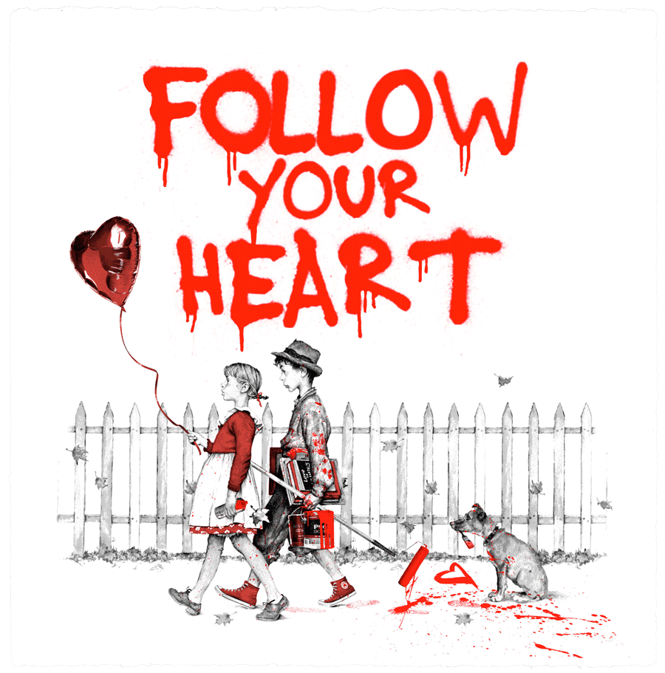
I'm Yours - Follow Your Heart
Archival Paper with Deckled Edges
22 x 22 in.
Available in 3 Colors (Red, Blue, Pink)
6-Color Screenprint with 1 Hand-Finished Stencil Layer
Edition of 20
AP Edition of 3
Certificate of Authenticity
Signed and thumb printed by the Artist
$800.00 / $1,600.00 (AP)
SOLD OUT
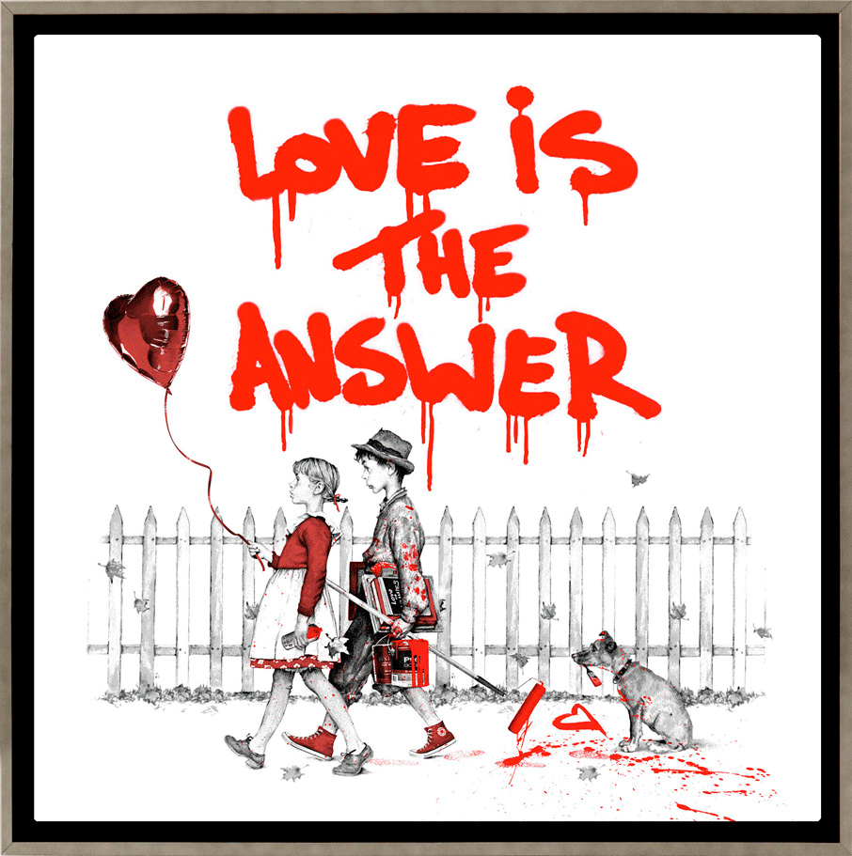
I'm Yours - Love Is The Answer
Framed Canvas
22 x 22 in.
All 3 variants available in 3 Colors (Red, Blue, Pink)
6-Color Screenprint with 1 Hand-Finished Stencil Layer
Editions of 3
Certificate of Authenticity
Signed and thumb printed by the Artist
$6,000.00
SOLD OUT
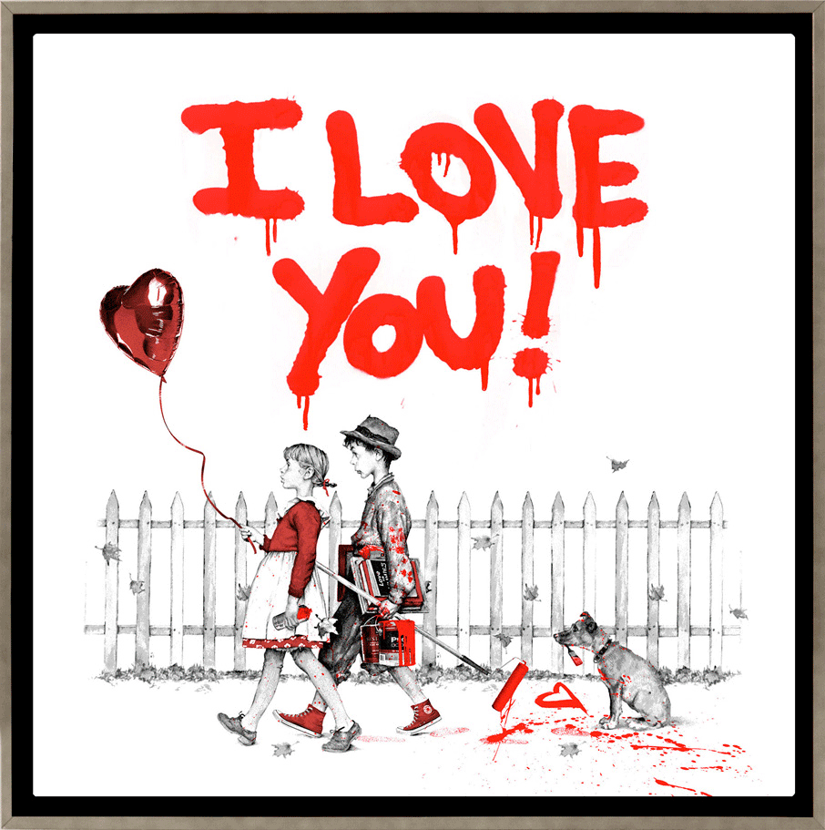
I'm Yours - I Love You
Framed Canvas
22 x 22 in.
All 3 variants available in 3 Colors (Red, Blue, Pink)
6-Color Screenprint with 1 Hand-Finished Stencil Layer
Editions of 3
Certificate of Authenticity
Signed and thumb printed by the Artist
$6,000.00
SOLD OUT
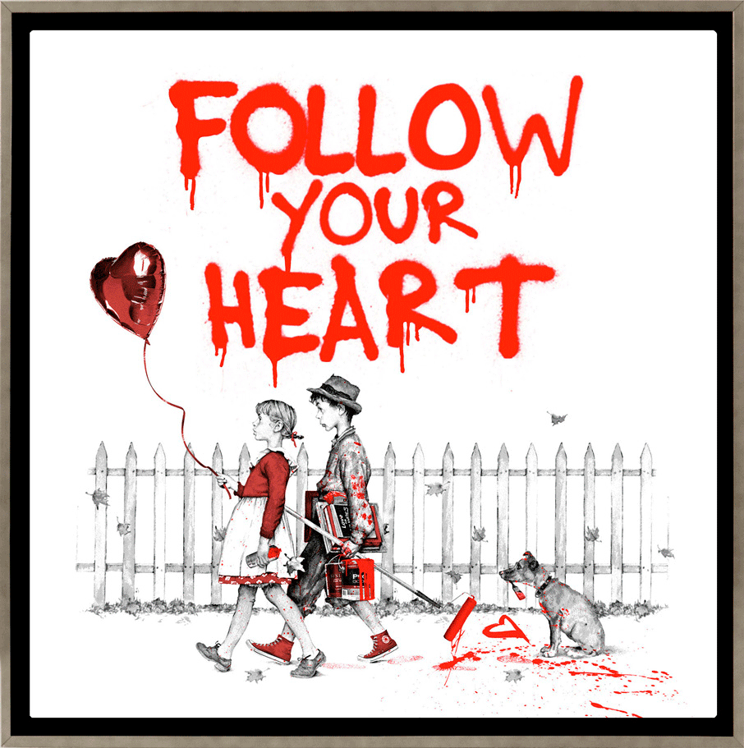
I'm Yours - Follow Your Heart
Framed Canvas
22 x 22 in.
All 3 variants available in 3 Colors (Red, Blue, Pink)
6-Color Screenprint with 1 Hand-Finished Stencil Layer
Editions of 3
Certificate of Authenticity
Signed and thumb printed by the Artist
$6,000.00
SOLD OUT
"Illustration(s) SEPS. © Licensed by Curtis Licensing"

