Shop
Author | Developer_1
Date | 2021-12-22 16:50:36
Categories

INCOGNITO
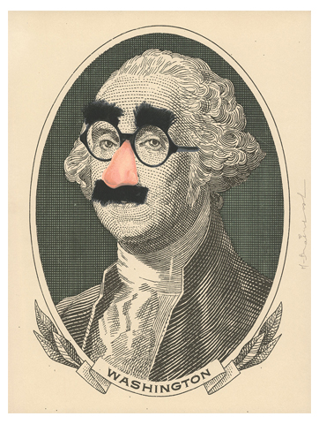
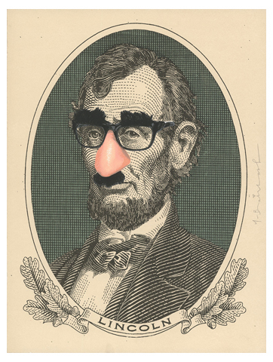
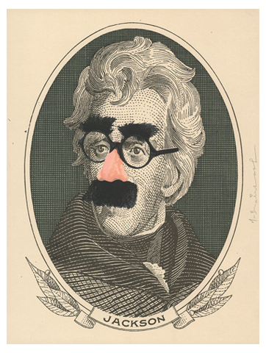
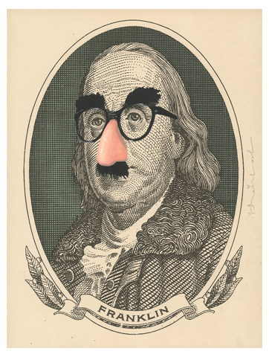

Metadata
inline_featured_image | 0
nectar-metabox-portfolio-display | all
nectar-metabox-portfolio-display-sortable | off

