News
Date | 2017-06-19 09:55:45

RECENT NEWS

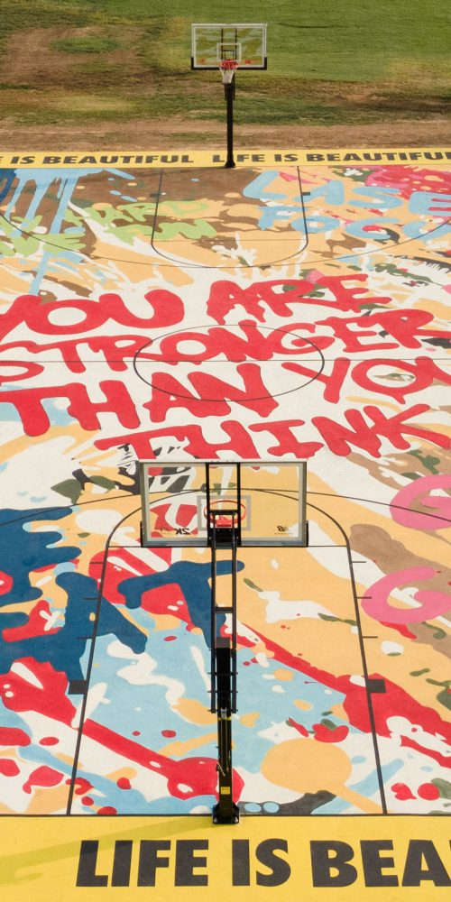News
11/08/2021

MBW x Kawhi Leonard x New Balance
JTNDY2VudGVyJTNFJTNDcCUyMGNsYXNzJTNEJTIyYmxvZy10YWclMjIlM0VNdXJhbCUzQyUyRnAlM0UlM0MlMkZjZW50ZXIlM0U= MBW x Kawhi Leonard x New Balance November 3, 2021…
Developer_1
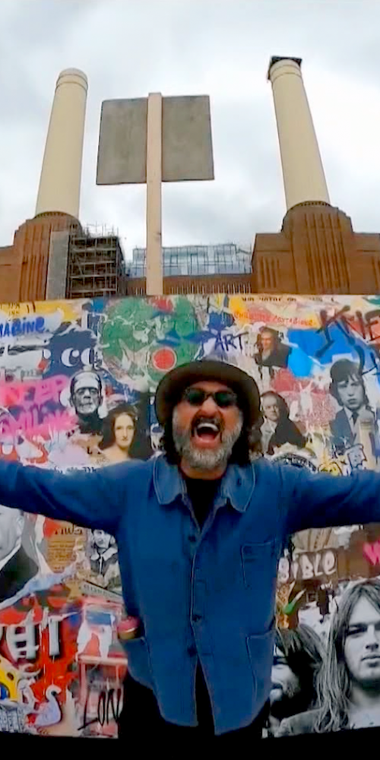News
10/13/2021

Battersea Power Station
JTNDY2VudGVyJTNFJTNDcCUyMGNsYXNzJTNEJTIyYmxvZy10YWclMjIlM0VNdXJhbCUzQyUyRnAlM0UlM0MlMkZjZW50ZXIlM0U= Battersea Power Station Oct 5th, 2021 To commemorate the…
Developer_1
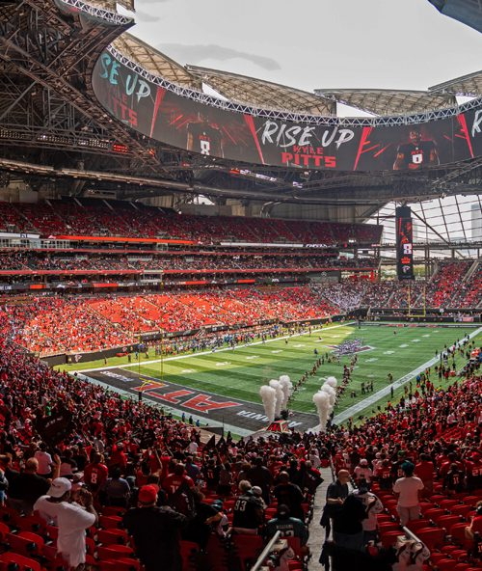News
10/13/2021

Atlanta is Beautiful
JTNDY2VudGVyJTNFJTNDcCUyMGNsYXNzJTNEJTIyYmxvZy10YWclMjIlM0VNdXJhbCUzQyUyRnAlM0UlM0MlMkZjZW50ZXIlM0U= Atlanta Is Beautiful September 15th, 2021 The Mercedes-Benz Stadium…
Developer_1
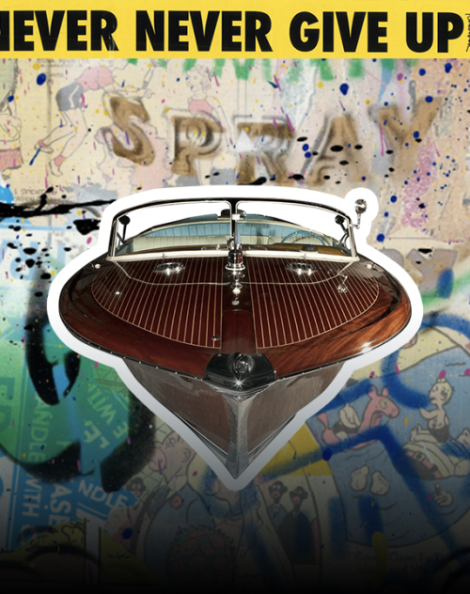News
07/02/2021

Mr. Brainwash x Bellini
JTNDY2VudGVyJTNFJTNDcCUyMGNsYXNzJTNEJTIyYmxvZy10YWclMjIlM0VDb2xsYWJvcmF0aW9uJTNDJTJGcCUzRSUzQyUyRmNlbnRlciUzRQ== Mr. Brainwash x Bellini May 25th, 2021 The 3rd…
Developer_1
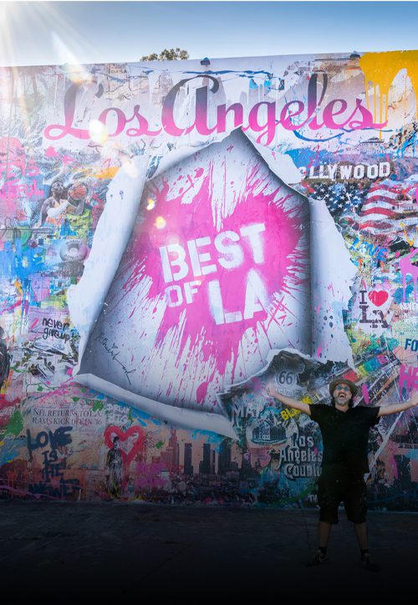News
07/24/2020

Best of L.A. 2020
JTNDY2VudGVyJTNFJTNDcCUyMGNsYXNzJTNEJTIyYmxvZy10YWclMjIlM0VNdXJhbCUzQyUyRnAlM0UlM0MlMkZjZW50ZXIlM0U= Best of L.A. 2020 July 21, 2020 Mr. Brainwash…
Developer_1
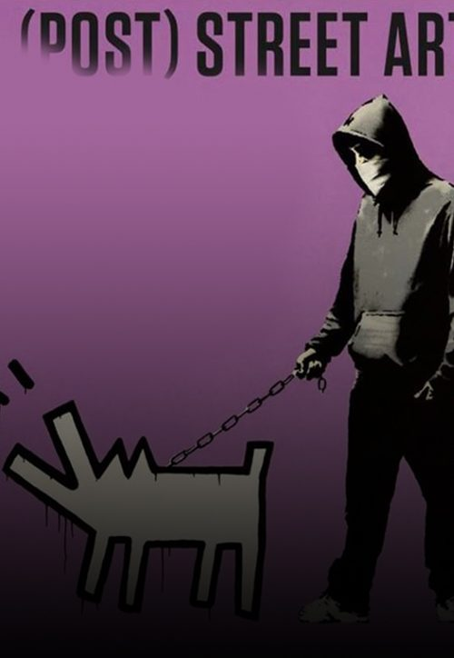News
12/23/2019

Naples Museum Celebrates Street Art
The PAN of Naples chooses to create the exhibition « Banksy…
Developer_1
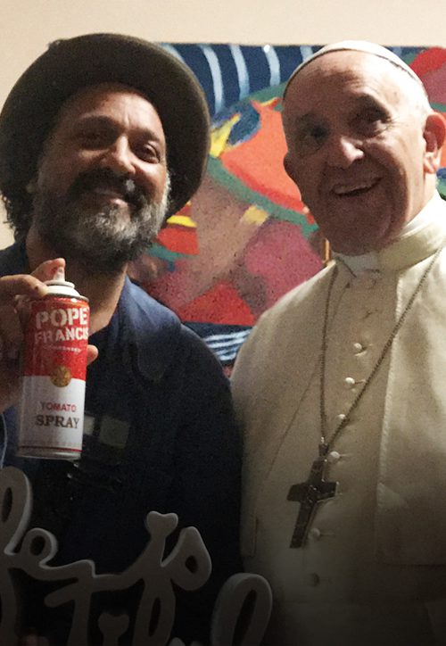News
12/21/2019

Pope Art
The Vatican may not be known for its contemporary art.…
Developer_1
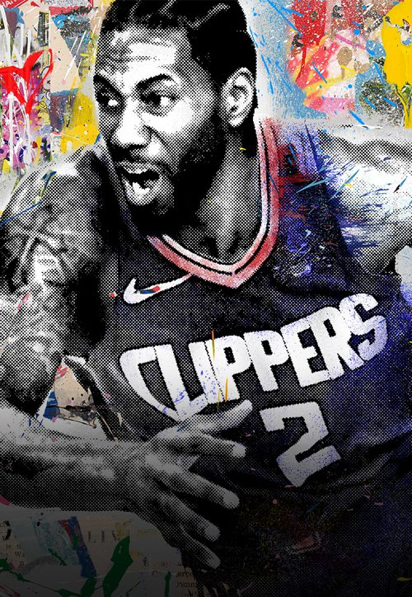News
11/21/2019

LA Clippers
To pay tribute to our great city, and our city’s…
Developer_1
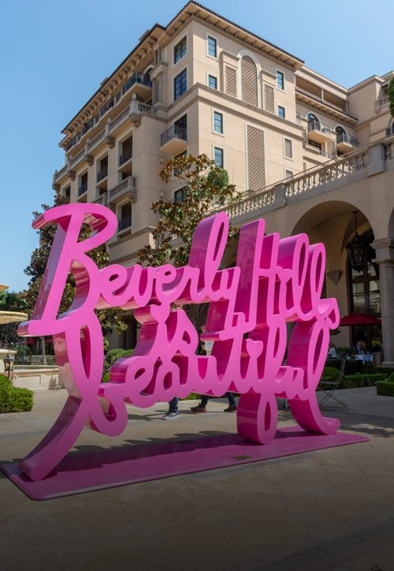News
11/21/2019

Beverly Hills is Beautiful
Commissioned by the city of Beverly Hills, Mr. Brainwash was…
Developer_1
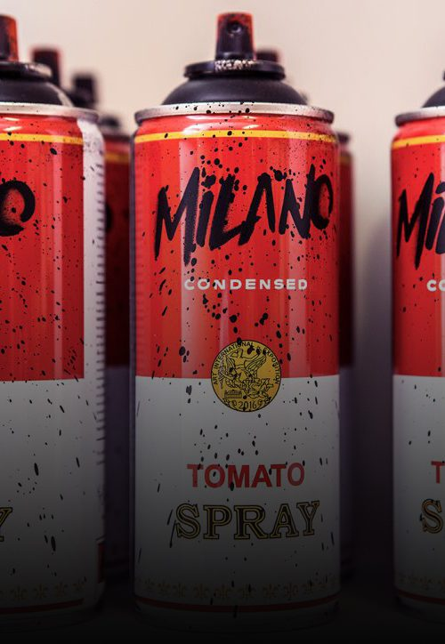News
02/12/2019

Milan is beautiful 2019
For his first major Italian debut, Mr. Brainwash was featured…
Developer_1
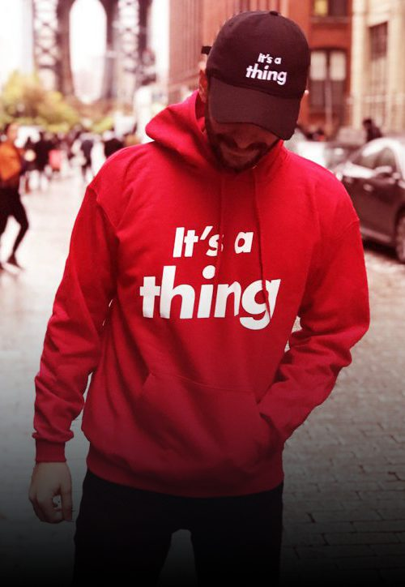News
12/31/2018

It’s A Thing
In New York City, the Starrett-Lehigh skyrise became a multi-story…
Developer_1
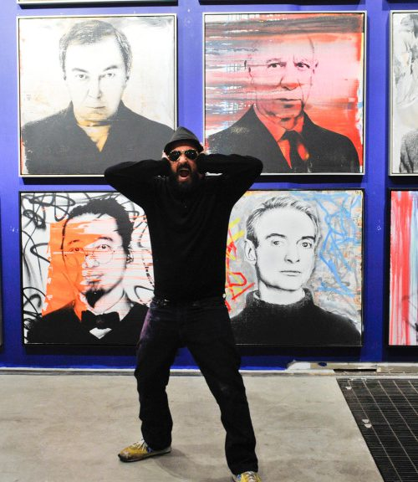News
11/28/2018

Miami Art Basel
Mr. Brainwash made his annual pilgrimage to Art Basel, making…
Developer_1
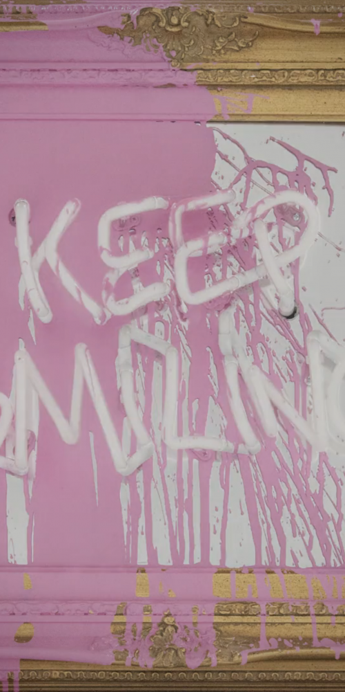News
10/30/2018

London 2018
To debut a brand-new series of neons on framed mirror…
Developer_1
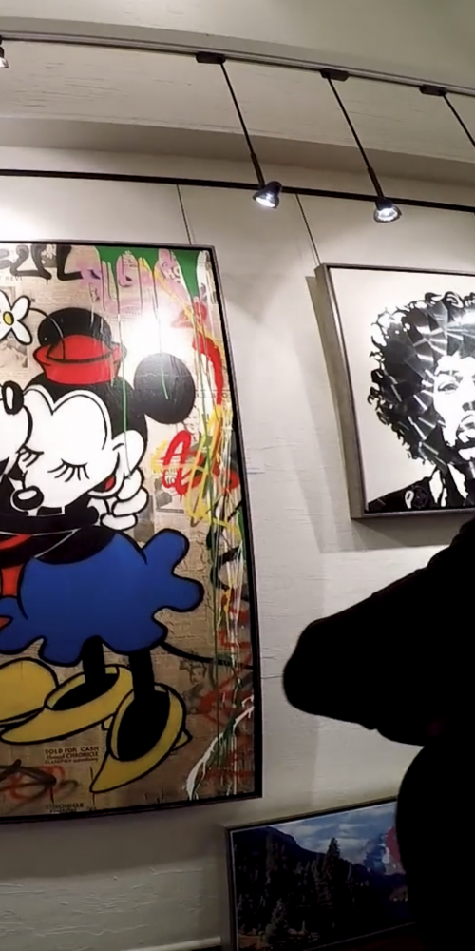News
09/30/2018

Aspen
Take a behind the scenes look at the curated takeover…
Developer_1
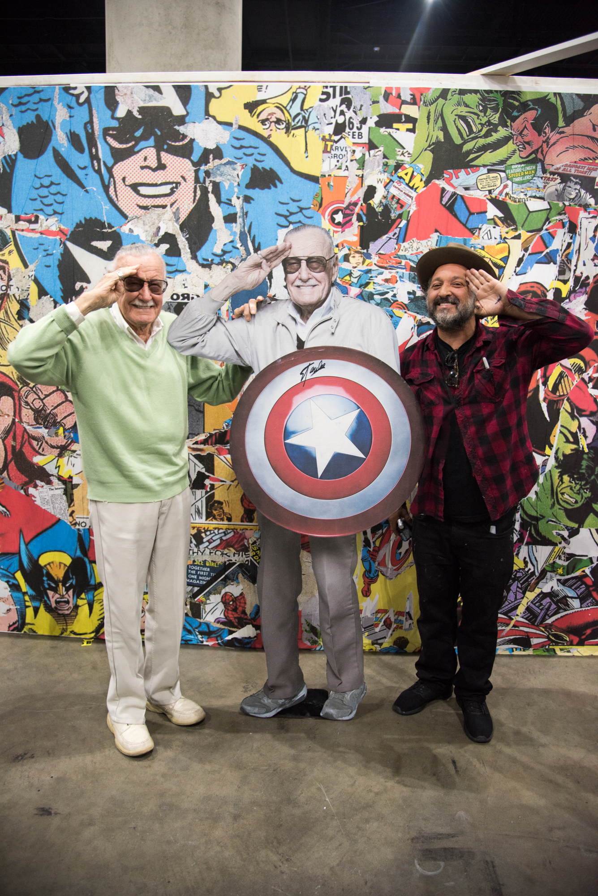News
11/07/2017

Mr. Brainwash x Stan Lee at LA Comic Con
Stan Lee, the Godfather of Marvel Comics swung by Mr…
BrainWash
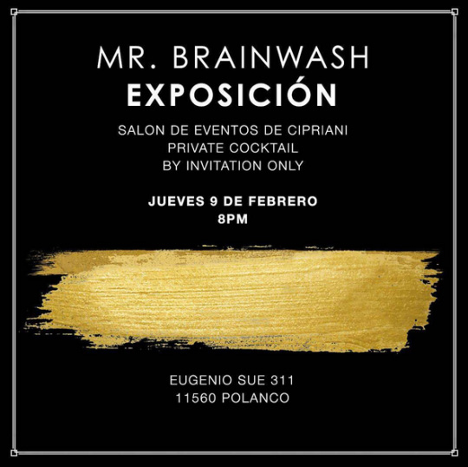News
10/23/2017

Mexico Is Beautiful
Mr. Brainwash returns to Mexico City with a solo exhibition…
Developer_1
News
10/16/2017

amfAR Gala Los Angeles
Mr Brainwash donated a painting featuring some of his most…
BrainWash
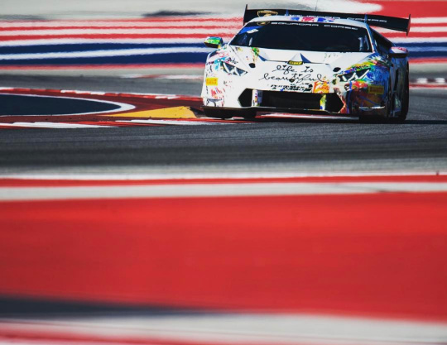News
05/22/2017

Mr. Brainwash x Lamborghini
Mr Brainwash partnered with Lamborghini to create a skin for…
BrainWash
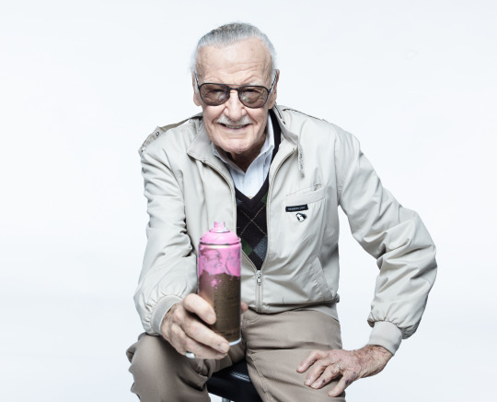News
04/27/2017

Stan Lee Visits Mr. Brainwash
The Godfather of Marvel Comics swung by West Hollywood for…
BrainWash
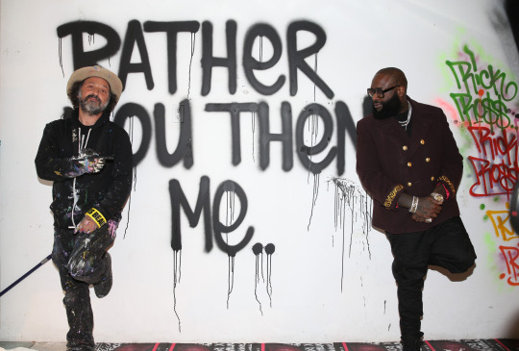News
03/31/2017

Rick Ross Party
In celebration of the release of his 9th studio album,…
BrainWash
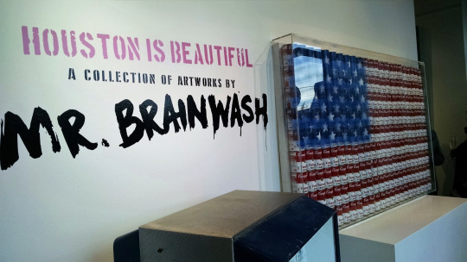News
01/27/2017

Houston is Beautiful
Mr Brainwash debuted his Houston-inspired pieces on April 27th 2017…
BrainWash
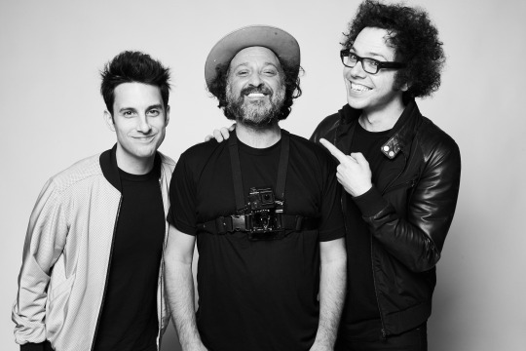News
01/17/2017

A Great Big World visits Mr. Brainwash
Ian Axel and Chad King, better known for their music…
BrainWash
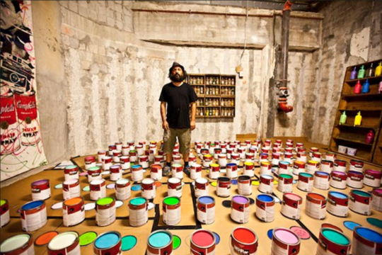News
01/12/2017

Warhol x Mr. Brainwash Gallery Showing
Since his first art show in Los Angeles, Mr Brainwash’s…
BrainWash
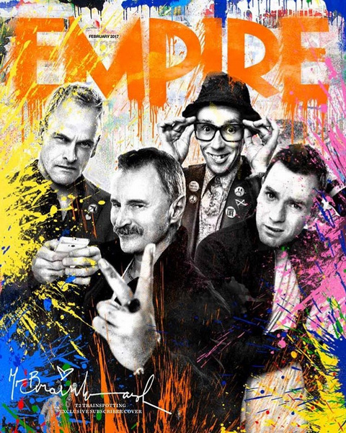News
12/28/2016

Trainspotting 2 on the cover of Empire Magazine
TRAINSPOTTING 2 ON THE COVER OF EMPIRE MAGAZINE December 28,…
BrainWash
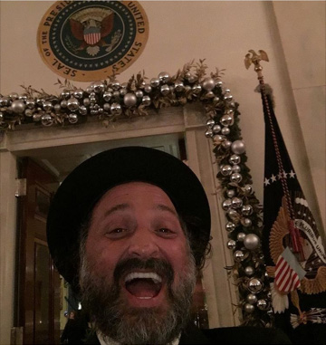News
12/14/2016

Mr. Brainwash visits the White House
To end a very eventful and successful year, in December…
BrainWash
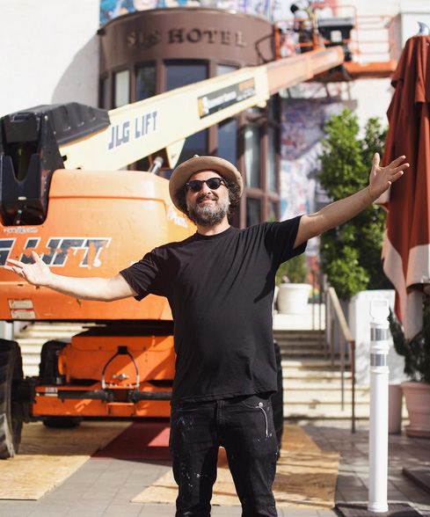News
12/01/2016

Art Basel: Miami 2016
Mr Brainwash returned to Art Basel Miami once again, bringing…
BrainWash
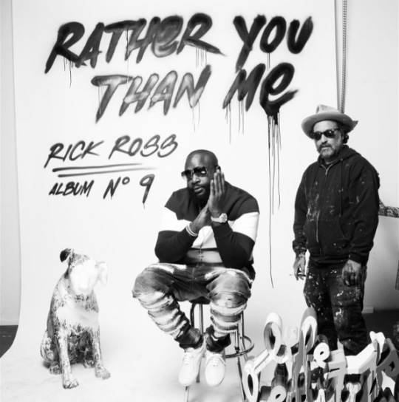News
11/22/2016

Rick Ross, Rather You Than Me
Mr Brainwash and longtime friend Rick Ross came together in…
BrainWash
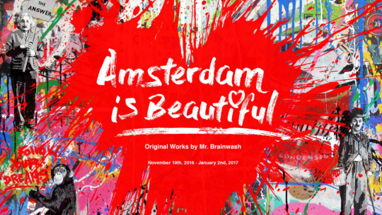News
11/10/2016

Amsterdam is Beautiful
JTNDY2VudGVyJTNFJTNDcCUyMGNsYXNzJTNEJTIyYmxvZy10YWclMjIlM0VNdXJhbCUzQyUyRnAlM0UlM0MlMkZjZW50ZXIlM0U= Amsterdam is Beautiful November 10, 2016 This was the…
BrainWash
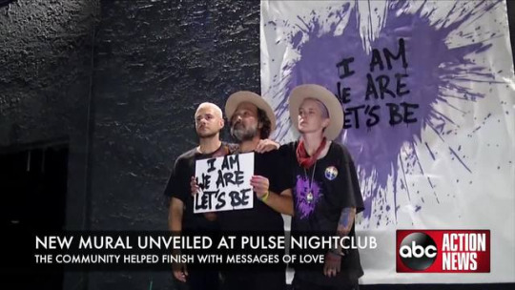News
10/19/2016

Pulse Night Club, Orlando, FL
JTNDY2VudGVyJTNFJTNDcCUyMGNsYXNzJTNEJTIyYmxvZy10YWclMjIlM0VNdXJhbCUzQyUyRnAlM0UlM0MlMkZjZW50ZXIlM0U= October 19 , 2016 In honor of the 49…
BrainWash
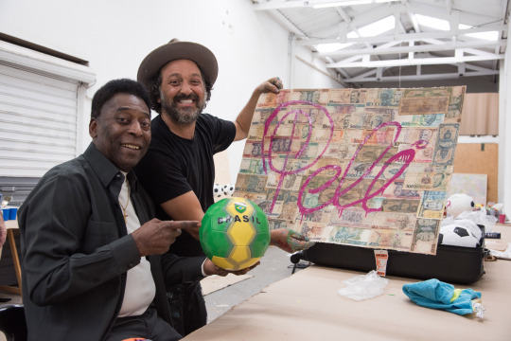News
08/26/2016

Pelé x Mr Brainwash Collaboration
JTNDY2VudGVyJTNFJTNDcCUyMGNsYXNzJTNEJTIyYmxvZy10YWclMjIlM0VDb2xsYWJvcmF0aW9uJTNDJTJGcCUzRSUzQyUyRmNlbnRlciUzRQ== Pelé x Mr Brainwash Collaboration August 26, 2016 A…
BrainWash
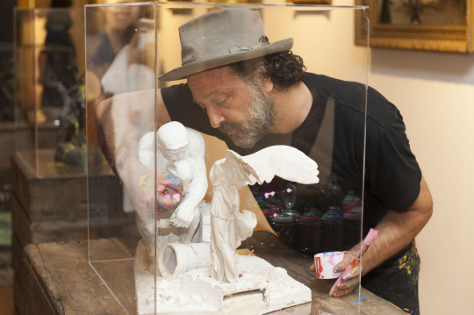News
06/21/2016

Solo Exhibit at ARA Museum (Seoul, South Korea)
Solo Exhibit at ARA Museum (Seoul, South Korea) June 21,…
BrainWash
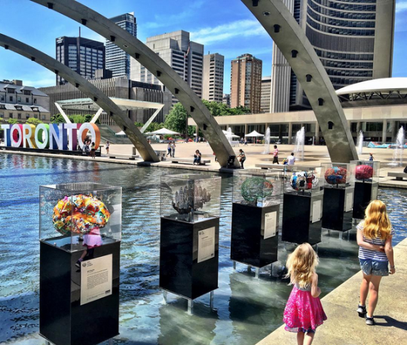News
06/04/2016

Donation to The Brain Project Fundraiser
JTNDY2VudGVyJTNFJTNDcCUyMGNsYXNzJTNEJTIyYmxvZy10YWclMjIlM0VNdXJhbCUzQyUyRnAlM0UlM0MlMkZjZW50ZXIlM0U= Donation to The Brain Project Fundraiser Jan 4 ,…
BrainWash
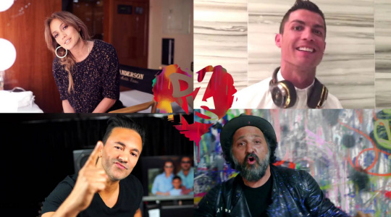News
05/27/2016

Features in “Don’t You Need Somebody” Music Video by RedOne
JTNDY2VudGVyJTNFJTNDcCUyMGNsYXNzJTNEJTIyYmxvZy10YWclMjIlM0VWaWRlbyUzQyUyRnAlM0UlM0MlMkZjZW50ZXIlM0U= Features in “Don’t You Need Somebody” Music Video by RedOne…
BrainWash
News
04/15/2016

amfAR
JTNDY2VudGVyJTNFJTNDcCUyMGNsYXNzJTNEJTIyYmxvZy10YWclMjIlM0VDb2xsYWJvcmF0aW9uJTNDJTJGcCUzRSUzQyUyRmNlbnRlciUzRQ== amfAR April 15, 2016 Mr Brainwash has been a…
BrainWash
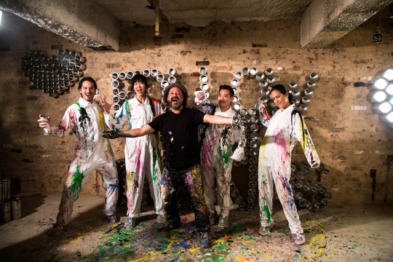News
03/21/2016

Art Basel Hong Kong
JTNDY2VudGVyJTNFJTNDcCUyMGNsYXNzJTNEJTIyYmxvZy10YWclMjIlM0VDb2xsYWJvcmF0aW9uJTNDJTJGcCUzRSUzQyUyRmNlbnRlciUzRQ== Art Basel - Hong Kong March 21, 2016 Art…
BrainWash
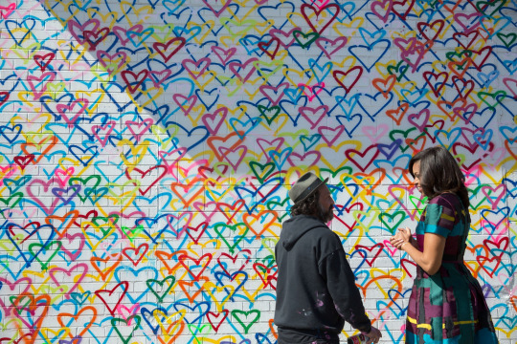News
03/11/2016

Mural in Washington D.C. For International Women’s Day
JTNDY2VudGVyJTNFJTNDcCUyMGNsYXNzJTNEJTIyYmxvZy10YWclMjIlM0VDb2xsYWJvcmF0aW9uJTNDJTJGcCUzRSUzQyUyRmNlbnRlciUzRQ== Mural in Washington D.C. For International Women’s Day March…
BrainWash
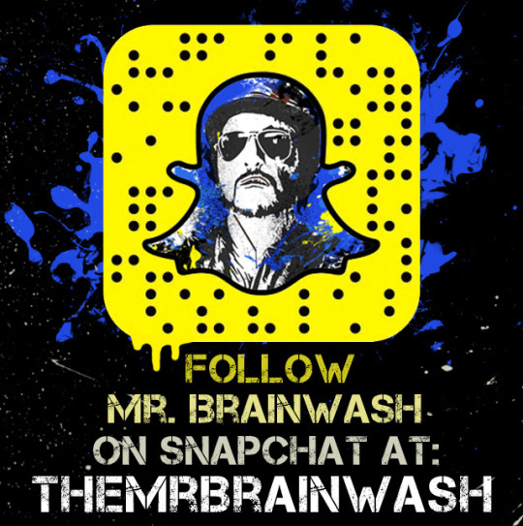News
02/25/2016

Snapchat
JTNDY2VudGVyJTNFJTNDcCUyMGNsYXNzJTNEJTIyYmxvZy10YWclMjIlM0VDb2xsYWJvcmF0aW9uJTNDJTJGcCUzRSUzQyUyRmNlbnRlciUzRQ== Snapchat February 25, 2016 DJ Khaled, also known…
BrainWash
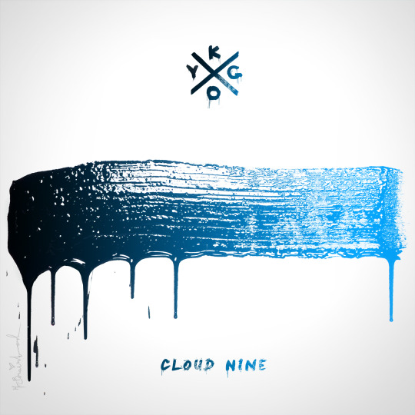News
01/05/2016

Collaboration with Kygo for “Cloud 9″ Album Cover
JTNDY2VudGVyJTNFJTNDcCUyMGNsYXNzJTNEJTIyYmxvZy10YWclMjIlM0VDb2xsYWJvcmF0aW9uJTNDJTJGcCUzRSUzQyUyRmNlbnRlciUzRQ== Collaboration with Kygo for “Cloud 9″ Album Cover January 5,…
BrainWash
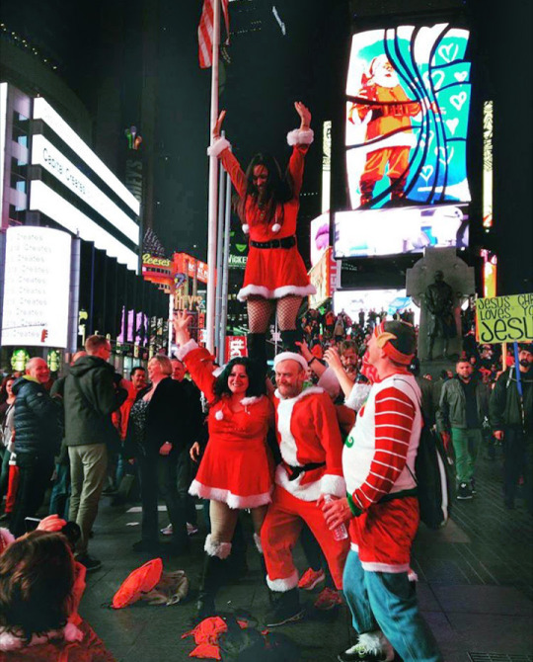News
12/25/2015

Coca-Cola Christmas Times Square Billboard
JTNDY2VudGVyJTNFJTNDcCUyMGNsYXNzJTNEJTIyYmxvZy10YWclMjIlM0VDb2xsYWJvcmF0aW9uJTNDJTJGcCUzRSUzQyUyRmNlbnRlciUzRQ== Coca-Cola Christmas Times Square Billboard December 5, 2015 During…
BrainWash
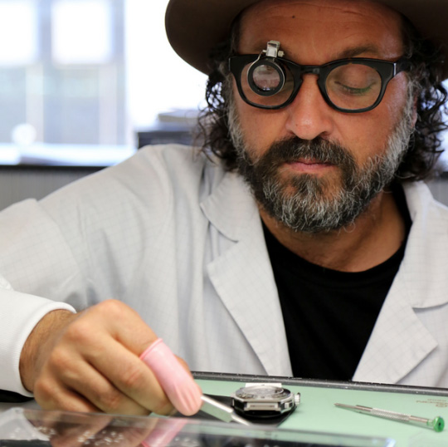News
12/04/2015

Hublot Collaboration
JTNDY2VudGVyJTNFJTNDcCUyMGNsYXNzJTNEJTIyYmxvZy10YWclMjIlM0VDb2xsYWJvcmF0aW9uJTNDJTJGcCUzRSUzQyUyRmNlbnRlciUzRQ== Hublot Collaboration December 4, 2015 Hubolt and Mr Brainwash…
BrainWash
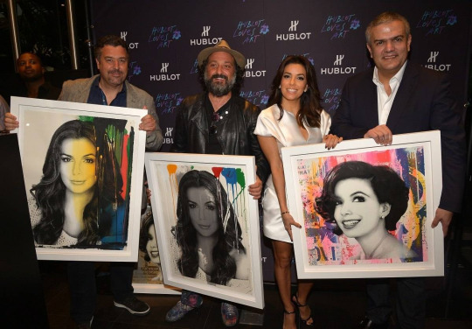News
12/01/2015

Art Basel Miami
JTNDY2VudGVyJTNFJTNDcCUyMGNsYXNzJTNEJTIyYmxvZy10YWclMjIlM0VDb2xsYWJvcmF0aW9uJTNDJTJGcCUzRSUzQyUyRmNlbnRlciUzRQ== Art Basel - Miami December 1, 2015 Mr Brainwash…
BrainWash
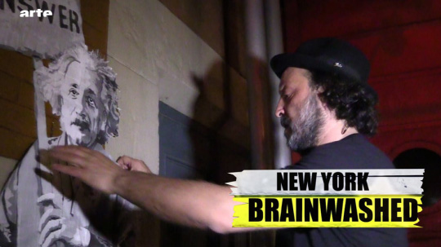News
10/01/2015

Features in 8th Episode of Arte Creative Series
JTNDY2VudGVyJTNFJTNDcCUyMGNsYXNzJTNEJTIyYmxvZy10YWclMjIlM0VDb2xsYWJvcmF0aW9uJTNDJTJGcCUzRSUzQyUyRmNlbnRlciUzRQ== Features in 8th Episode of Arte Creative Series October…
BrainWash
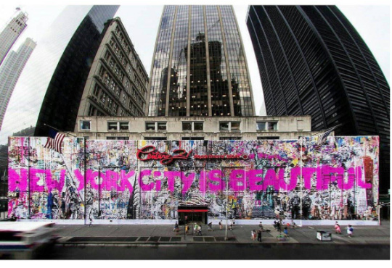News
09/11/2015

Tribute Mural for 9/11
JTNDY2VudGVyJTNFJTNDcCUyMGNsYXNzJTNEJTIyYmxvZy10YWclMjIlM0VDb2xsYWJvcmF0aW9uJTNDJTJGcCUzRSUzQyUyRmNlbnRlciUzRQ== Tribute Mural for 9/11 September 11, 2015 Mr Brainwash…
BrainWash
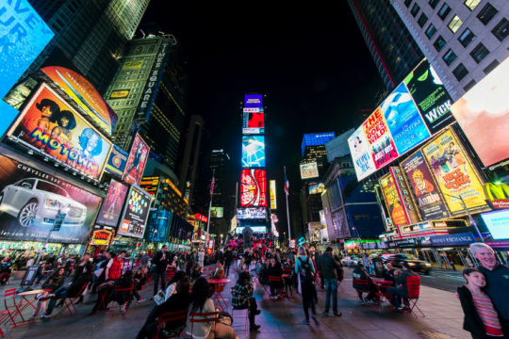News
08/01/2015

Mr Brainwash Collaborates With Coca-Cola For Times Square
JTNDY2VudGVyJTNFJTNDcCUyMGNsYXNzJTNEJTIyYmxvZy10YWclMjIlM0VDb2xsYWJvcmF0aW9uJTNDJTJGcCUzRSUzQyUyRmNlbnRlciUzRQ== Mr Brainwash Collaborates With Coca-Cola For Times Square August…
BrainWash
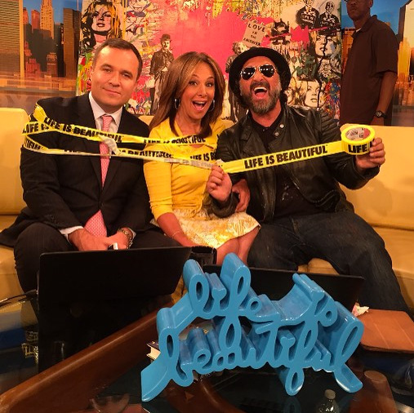News
07/20/2015

Guests on Good Day New York
JTNDY2VudGVyJTNFJTNDcCUyMGNsYXNzJTNEJTIyYmxvZy10YWclMjIlM0VDb2xsYWJvcmF0aW9uJTNDJTJGcCUzRSUzQyUyRmNlbnRlciUzRQ== Guests on Good Day New York July 20, 2015…
BrainWash
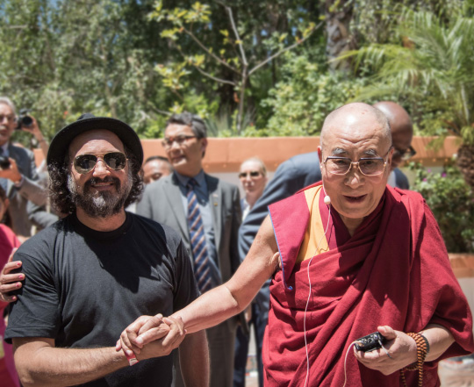News
07/04/2015

Mr Brainwash Meets the Dalai Lama
JTNDY2VudGVyJTNFJTNDcCUyMGNsYXNzJTNEJTIyYmxvZy10YWclMjIlM0VDb2xsYWJvcmF0aW9uJTNDJTJGcCUzRSUzQyUyRmNlbnRlciUzRQ== Mr Brainwash Meets the Dalai Lama July 4, 2015…
BrainWash
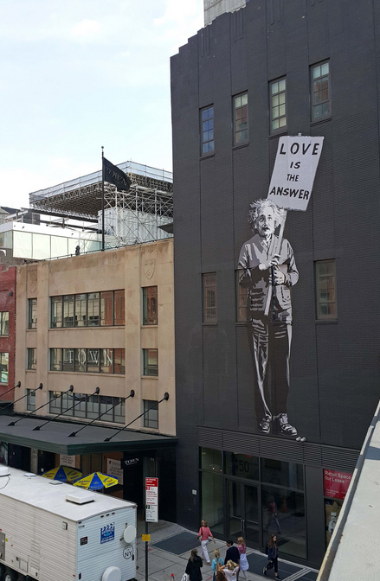News
06/18/2015

“Life Is Beautiful” Pop-Up Show (NY)
JTNDY2VudGVyJTNFJTNDcCUyMGNsYXNzJTNEJTIyYmxvZy10YWclMjIlM0VDb2xsYWJvcmF0aW9uJTNDJTJGcCUzRSUzQyUyRmNlbnRlciUzRQ== “Life Is Beautiful” Pop-Up Show (NY) June 18, 2015…
BrainWash
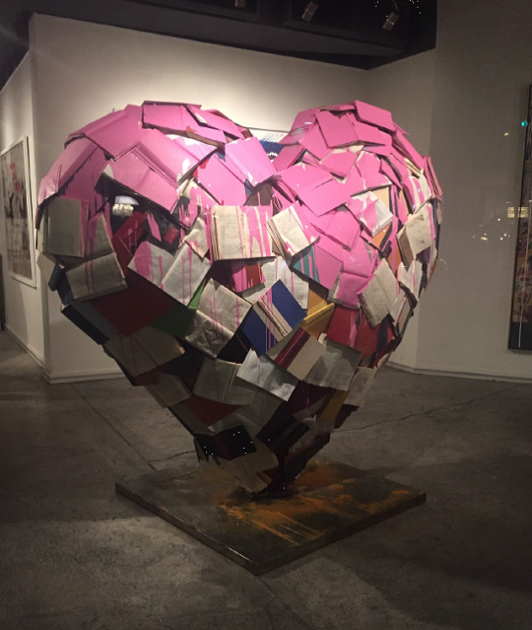News
05/22/2015

Contribution to LA Pride Festival
JTNDY2VudGVyJTNFJTNDcCUyMGNsYXNzJTNEJTIyYmxvZy10YWclMjIlM0VDb250cmlidXRpb24lM0MlMkZwJTNFJTNDJTJGY2VudGVyJTNF Contribution to LA Pride FestivalC March 22, 2015 Mr…
BrainWash
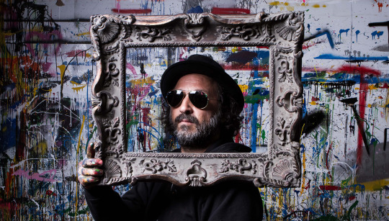News
05/15/2015

Collaboration with Sunglass Hut
JTNDY2VudGVyJTNFJTNDcCUyMGNsYXNzJTNEJTIyYmxvZy10YWclMjIlM0VDb2xsYWJvcmF0aW9uJTNDJTJGcCUzRSUzQyUyRmNlbnRlciUzRQ== Collaboration with Sunglass Hut May 15, 2015 Mr Brainwash…
BrainWash
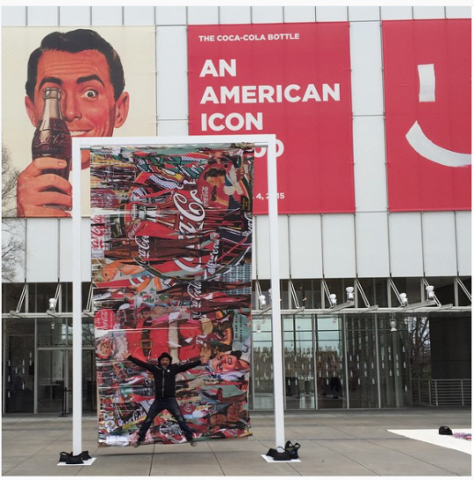News
02/25/2015

Coca-Cola 100th Anniversary
JTNDY2VudGVyJTNFJTNDcCUyMGNsYXNzJTNEJTIyYmxvZy10YWclMjIlM0VDb2xsYWJvcmF0aW9uJTNDJTJGcCUzRSUzQyUyRmNlbnRlciUzRQ== Coca-Cola 100th Anniversary February 25, 2015 For their 100th…
BrainWash
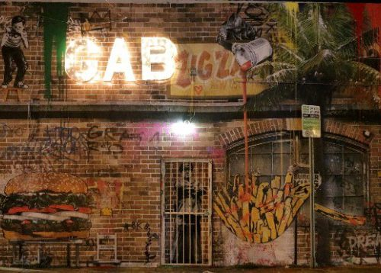News
12/04/2014

Mural on Burger King Wall (Art Basel Miami)
JTNDY2VudGVyJTNFJTNDcCUyMGNsYXNzJTNEJTIyYmxvZy10YWclMjIlM0VDb2xsYWJvcmF0aW9uJTNDJTJGcCUzRSUzQyUyRmNlbnRlciUzRQ== Mural on Burger King Wall (Art Basel Miami) December…
BrainWash
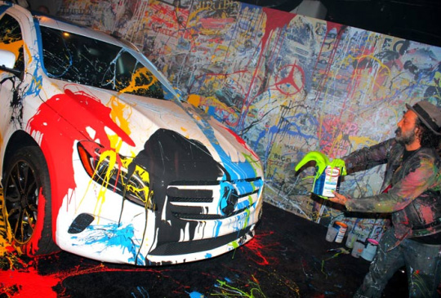News
11/26/2014

Collaboration and Performance with Mercedes-Benz
JTNDY2VudGVyJTNFJTNDcCUyMGNsYXNzJTNEJTIyYmxvZy10YWclMjIlM0VDb2xsYWJvcmF0aW9uJTNDJTJGcCUzRSUzQyUyRmNlbnRlciUzRQ== Collaboration and Performance with Mercedes-Benz November 26, 2014 Mr…
BrainWash
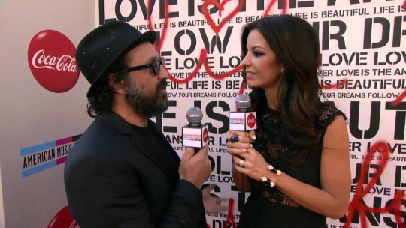News
11/23/2014

Mr Brainwash designs backdrop for Coca-Cola American Music Awards
JTNDY2VudGVyJTNFJTNDcCUyMGNsYXNzJTNEJTIyYmxvZy10YWclMjIlM0VDb2xsYWJvcmF0aW9uJTNDJTJGcCUzRSUzQyUyRmNlbnRlciUzRQ== Mr Brainwash designs backdrop for Coca-Cola American Music Awards…
BrainWash
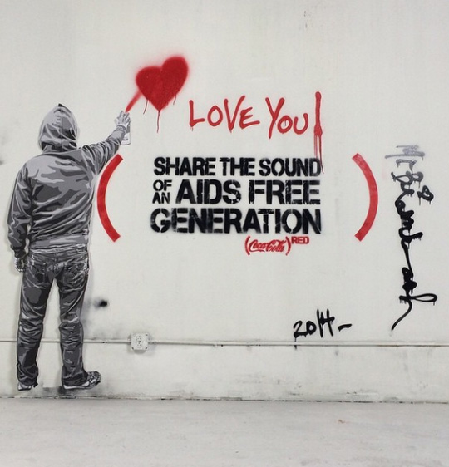News
11/17/2014

Wyclef Jean + AVICII’s “Divine Sorrow” for (RED)
JTNDY2VudGVyJTNFJTNDcCUyMGNsYXNzJTNEJTIyYmxvZy10YWclMjIlM0VDb2xsYWJvcmF0aW9uJTNDJTJGcCUzRSUzQyUyRmNlbnRlciUzRQ== Wyclef Jean + AVICII’s “Divine Sorrow” for (RED) November 17,…
BrainWash
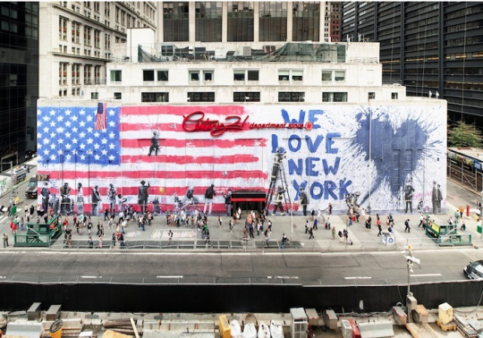News
09/11/2014

Tribute 9/11 Mural In NY
JTNDY2VudGVyJTNFJTNDcCUyMGNsYXNzJTNEJTIyYmxvZy10YWclMjIlM0VDb2xsYWJvcmF0aW9uJTNDJTJGcCUzRSUzQyUyRmNlbnRlciUzRQ== Levi’s - FADER Fort, NYC September 11, 2014 In…
BrainWash
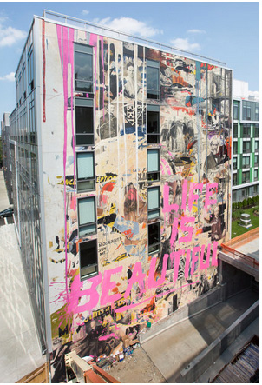News
07/18/2014

Mural In Brooklyn
JTNDY2VudGVyJTNFJTNDcCUyMGNsYXNzJTNEJTIyYmxvZy10YWclMjIlM0VDb2xsYWJvcmF0aW9uJTNDJTJGcCUzRSUzQyUyRmNlbnRlciUzRQ== Mural In Brooklyn July 18, 2014 Mr Brainwash commemorated…
BrainWash
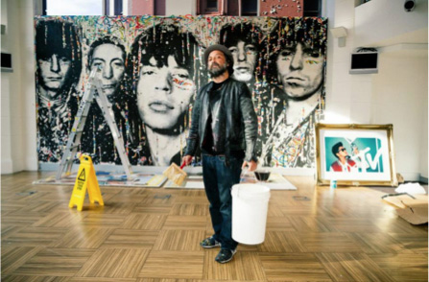News
05/22/2014

Semi-Permanent
JTNDY2VudGVyJTNFJTNDcCUyMGNsYXNzJTNEJTIyYmxvZy10YWclMjIlM0VDb2xsYWJvcmF0aW9uJTNDJTJGcCUzRSUzQyUyRmNlbnRlciUzRQ== Semi-Permanent May 22, 2014 In May 2014, Semi-Permanent, a…
BrainWash
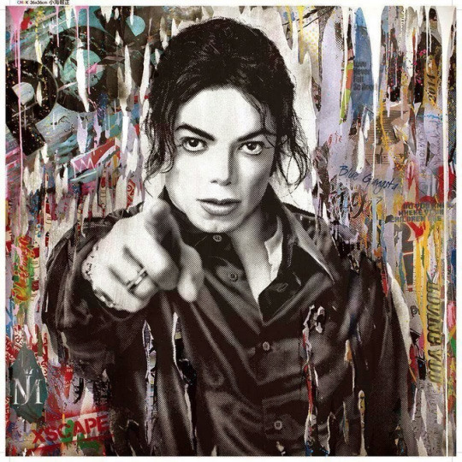News
05/13/2014

Michael Jackson’s “Xscape” Deluxe Edition Album Cover
JTNDY2VudGVyJTNFJTNDcCUyMGNsYXNzJTNEJTIyYmxvZy10YWclMjIlM0VDb2xsYWJvcmF0aW9uJTNDJTJGcCUzRSUzQyUyRmNlbnRlciUzRQ== Michael Jackson’s “Xscape” Deluxe Edition Album Cover May 13, 2014…
BrainWash
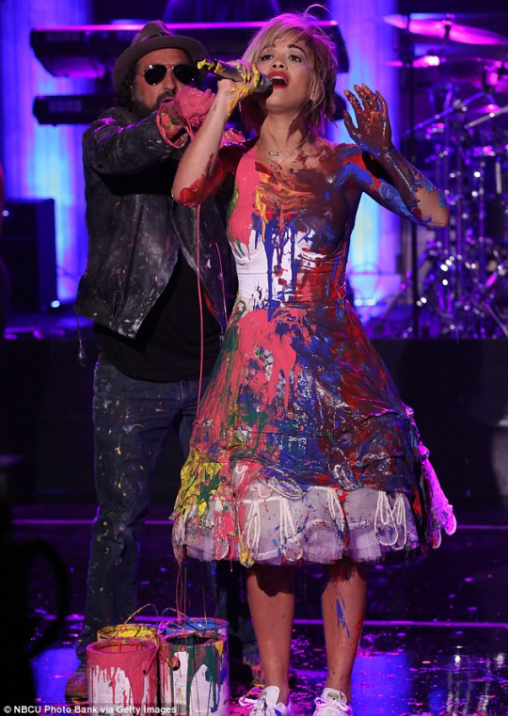News
04/22/2014

Live Painting Performance on Jimmy Fallon’s Late Night Show
JTNDY2VudGVyJTNFJTNDcCUyMGNsYXNzJTNEJTIyYmxvZy10YWclMjIlM0VUZWxldmlzaW9uJTNDJTJGcCUzRSUzQyUyRmNlbnRlciUzRQ== Live Painting Performance on Jimmy Fallon’s Late Night Show…
BrainWash
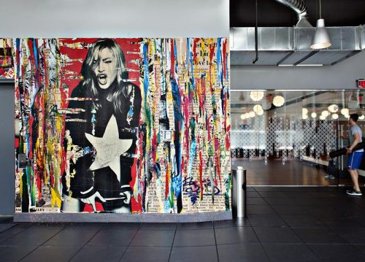News
02/01/2014

Madonna’s Hard Candy Gym Opening (Toronto & Mexico City)
JTNDY2VudGVyJTNFJTNDcCUyMGNsYXNzJTNEJTIyYmxvZy10YWclMjIlM0VDb2xsYWJvcmF0aW9uJTNDJTJGcCUzRSUzQyUyRmNlbnRlciUzRQ== MADONNA’S HARD CANDY GYM OPENING (TORONTO & MEXICO CITY)…
BrainWash
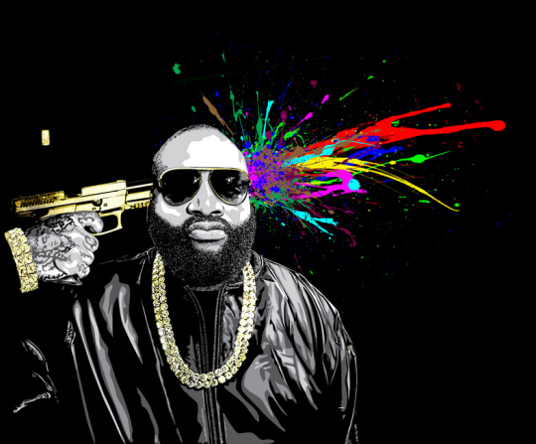News
10/02/2013

Rick Ross’ “Mastermind” Album Cover
JTNDY2VudGVyJTNFJTNDcCUyMGNsYXNzJTNEJTIyYmxvZy10YWclMjIlM0VBbGJ1bSUyMENvdmVyJTNDJTJGcCUzRSUzQyUyRmNlbnRlciUzRQ== Rick Ross’ “Mastermind” Album Cover October 2, 2013 Mr Brainwash…
BrainWash
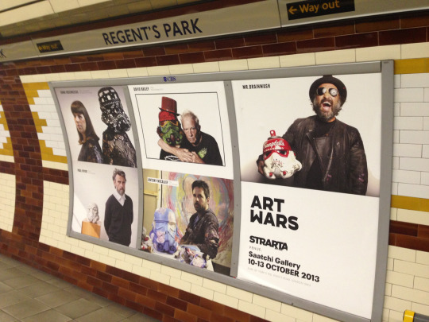News
10/01/2013

“Art Wars” Exhibition At Saatchi Gallery
JTNDY2VudGVyJTNFJTNDcCUyMGNsYXNzJTNEJTIyYmxvZy10YWclMjIlM0VFeGhpYml0aW9uJTNDJTJGcCUzRSUzQyUyRmNlbnRlciUzRQ== “Art Wars” Exhibition At Saatchi Gallery October 1, 2013…
BrainWash
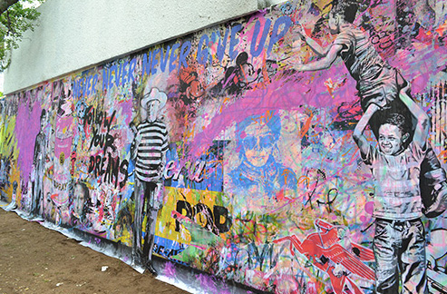News
09/01/2013

“Life is Beautiful” Solo Exhibit At Dieresis Contemporary Art Center
JTNDY2VudGVyJTNFJTNDcCUyMGNsYXNzJTNEJTIyYmxvZy10YWclMjIlM0VNdXJhbCUzQyUyRnAlM0UlM0MlMkZjZW50ZXIlM0U= “Life is Beautiful” Solo Exhibit At Dieresis Contemporary Art…
BrainWash
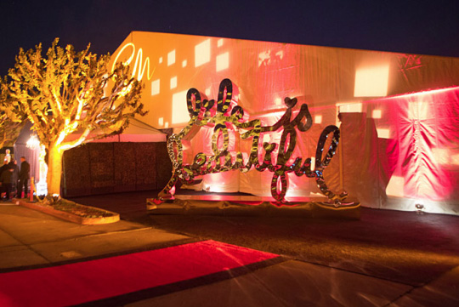News
02/24/2013

Oscars After Party Hosted By Seth MacFarlane
JTNDY2VudGVyJTNFJTNDcCUyMGNsYXNzJTNEJTIyYmxvZy10YWclMjIlM0VQYXJ0eSUzQyUyRnAlM0UlM0MlMkZjZW50ZXIlM0U= Oscars After Party Hosted By Seth MacFarlane Feburary 24,…
BrainWash
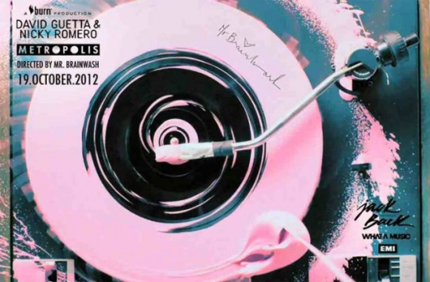News
10/19/2012

Mr Brainwash Directs David Guetta’s “Metropolis” Music Video
JTNDY2VudGVyJTNFJTNDcCUyMGNsYXNzJTNEJTIyYmxvZy10YWclMjIlM0VWaWRlbyUzQyUyRnAlM0UlM0MlMkZjZW50ZXIlM0U= Mr Brainwash Directs David Guetta’s “Metropolis” Music Video October 19,…
BrainWash
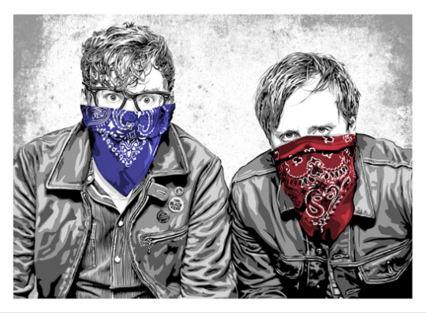News
10/05/2012

The Black Keys Poster
JTNDY2VudGVyJTNFJTNDcCUyMGNsYXNzJTNEJTIyYmxvZy10YWclMjIlM0VDb2xsYWJvcmF0aW9uJTNDJTJGcCUzRSUzQyUyRmNlbnRlciUzRQ== The Black Keys Poster October 5, 2012 In addition…
BrainWash
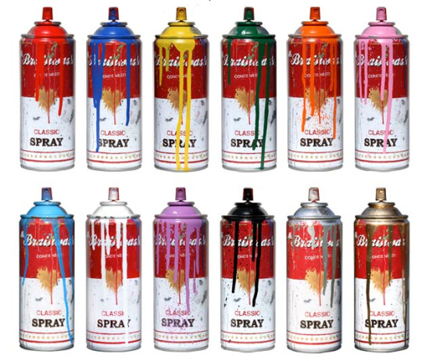News
09/24/2012

Exhibition At Opera Gallery In Dubai
JTNDY2VudGVyJTNFJTNDcCUyMGNsYXNzJTNEJTIyYmxvZy10YWclMjIlM0VFeGhpYml0JTNDJTJGcCUzRSUzQyUyRmNlbnRlciUzRQ== Exhibition At Opera Gallery In Dubai September 24, 2012…
BrainWash
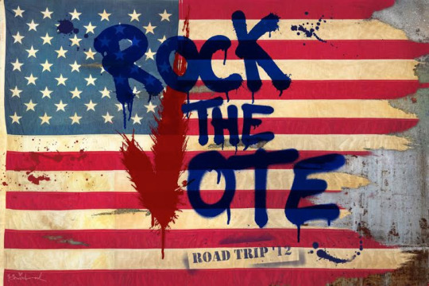News
08/28/2012

Rock The Vote – Road Trip 2012
JTNDY2VudGVyJTNFJTNDcCUyMGNsYXNzJTNEJTIyYmxvZy10YWclMjIlM0VSb2NrJTIwVGhlJTIwVm90ZSUzQyUyRnAlM0UlM0MlMkZjZW50ZXIlM0U= Rock The Vote - Road Trip 2012 Aug 28,…
BrainWash
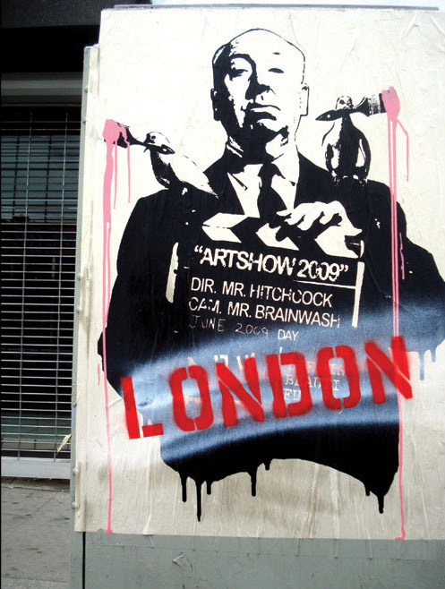News
08/05/2012

“Life is Beautiful” Solo Exhibit In Central London
When the Summer Olympics arrived and the whole world had…
BrainWash
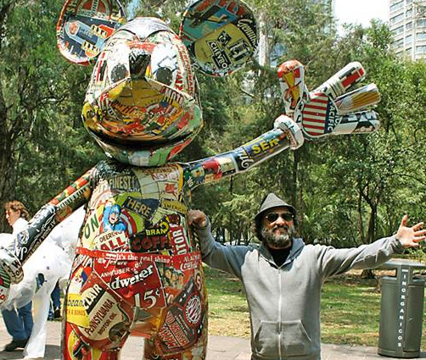News
04/18/2012

“Life is Beautiful” Solo Exhibit With Sotheby’s In Mexico City
JTNDY2VudGVyJTNFJTNDcCUyMGNsYXNzJTNEJTIyYmxvZy10YWclMjIlM0VFeGhpYml0JTNDJTJGcCUzRSUzQyUyRmNlbnRlciUzRQ== “Life is Beautiful” Solo Exhibit With Sotheby’s In Mexico…
BrainWash
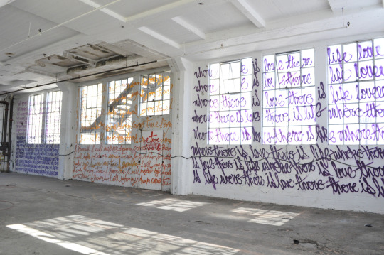News
12/22/2011

“Life Is Beautiful: Art Show 2011″ Solo Exhibit
JTNDY2VudGVyJTNFJTNDcCUyMGNsYXNzJTNEJTIyYmxvZy10YWclMjIlM0VTaG93JTNDJTJGcCUzRSUzQyUyRmNlbnRlciUzRQ== “Life Is Beautiful: Art Show 2011″ Solo Exhibit December…
BrainWash
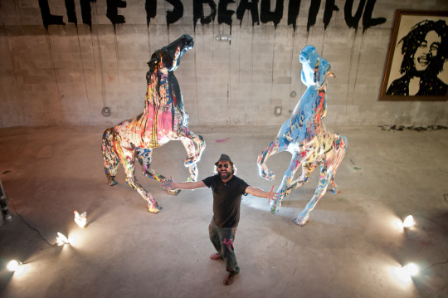News
12/01/2011

“Life Is Beautiful: Untitled” Pop-Up Show At Art Basel Miami
JTNDY2VudGVyJTNFJTNDcCUyMGNsYXNzJTNEJTIyYmxvZy10YWclMjIlM0VBcnQlMjBCYXNlbCUzQyUyRnAlM0UlM0MlMkZjZW50ZXIlM0U= “Life Is Beautiful: Untitled” Pop-Up Show At Art Basel…
BrainWash
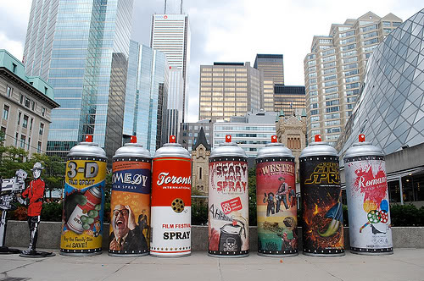News
09/18/2011

Toronto Film Festival
JTNDY2VudGVyJTNFJTNDcCUyMGNsYXNzJTNEJTIyYmxvZy10YWclMjIlM0VGZXN0aXZhbCUzQyUyRnAlM0UlM0MlMkZjZW50ZXIlM0U= Toronto Film Festival September 18, 2011 Mr Brainwash continued…
BrainWash
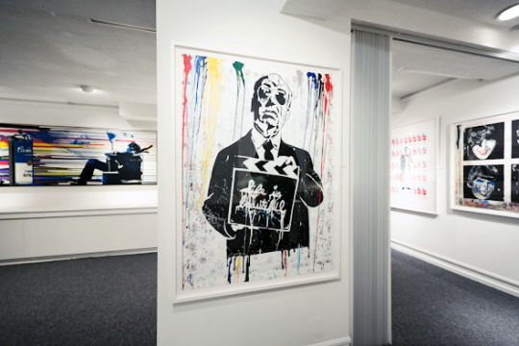News
09/08/2011

“Life Is Beautiful” Solo Show In Toronto
JTNDY2VudGVyJTNFJTNDcCUyMGNsYXNzJTNEJTIyYmxvZy10YWclMjIlM0VHYWxsZXJ5JTNDJTJGcCUzRSUzQyUyRmNlbnRlciUzRQ== “Life Is Beautiful” Solo Show In Toronto September 8,…
BrainWash
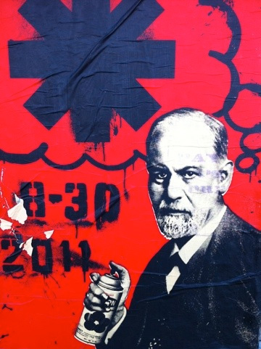News
07/26/2011

Mr Brainwash Collaborates With Red Hot Chili Peppers
JTNDY2VudGVyJTNFJTNDcCUyMGNsYXNzJTNEJTIyYmxvZy10YWclMjIlM0VNdXJhbCUzQyUyRnAlM0UlM0MlMkZjZW50ZXIlM0U= Mr Brainwash Collaborates With Red Hot Chili Peppers July…
BrainWash
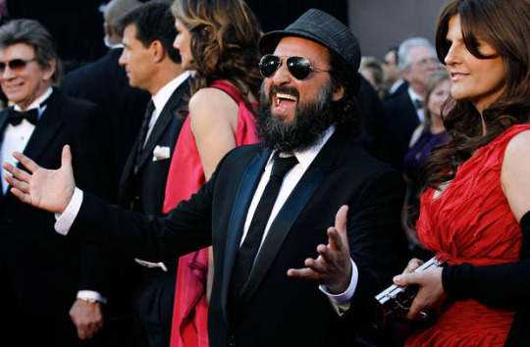News
02/27/2011

Mr Brainwash Goes To The Oscars
JTNDY2VudGVyJTNFJTNDcCUyMGNsYXNzJTNEJTIyYmxvZy10YWclMjIlM0VPc2NhcnMlM0MlMkZwJTNFJTNDJTJGY2VudGVyJTNF Mr Brainwash Goes To The Oscars Feburary 27, 2011…
BrainWash
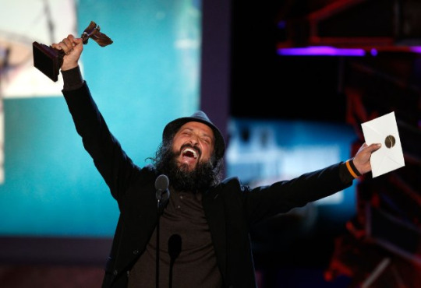News
02/26/2011

Independent Spirit Award for Exit Through The Gift Shop
JTNDY2VudGVyJTNFJTNDcCUyMGNsYXNzJTNEJTIyYmxvZy10YWclMjIlM0VBd2FyZCUzQyUyRnAlM0UlM0MlMkZjZW50ZXIlM0U= Independent Spirit Award for Exit Through The Gift Shop…
BrainWash
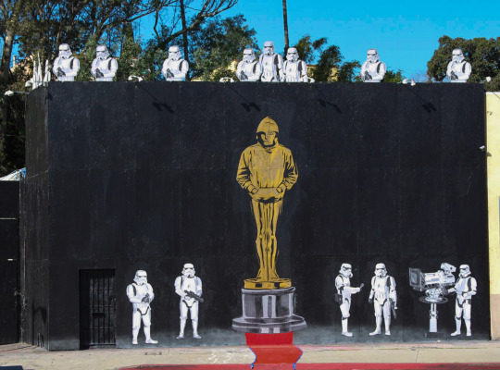News
01/29/2011

Mr Brainwash Paints Mural For The Oscars
JTNDY2VudGVyJTNFJTNDcCUyMGNsYXNzJTNEJTIyYmxvZy10YWclMjIlM0VNdXJhbCUzQyUyRnAlM0UlM0MlMkZjZW50ZXIlM0U= Mr Brainwash Paints Mural For The Oscars January 29,…
BrainWash
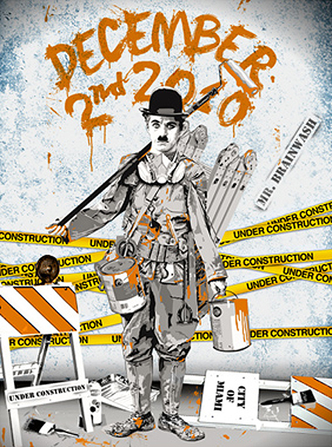News
12/02/2010

“Life is Beautiful: Under Construction” Pop Up Show At Art Basel Miami
JTNDY2VudGVyJTNFJTNDcCUyMGNsYXNzJTNEJTIyYmxvZy10YWclMjIlM0VBcnQlMjBCYXNlbCUzQyUyRnAlM0UlM0MlMkZjZW50ZXIlM0U= “Life is Beautiful: Under Construction” Pop Up Show At Art…
BrainWash
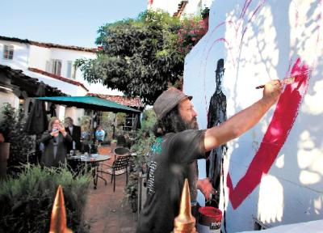News
10/12/2010

Carmel International Film Festival
JTNDY2VudGVyJTNFJTNDcCUyMGNsYXNzJTNEJTIyYmxvZy10YWclMjIlM0VNdXJhbCUzQyUyRnAlM0UlM0MlMkZjZW50ZXIlM0U= Carmel International Film Festival October 12, 2010 Mr Brainwash…
BrainWash
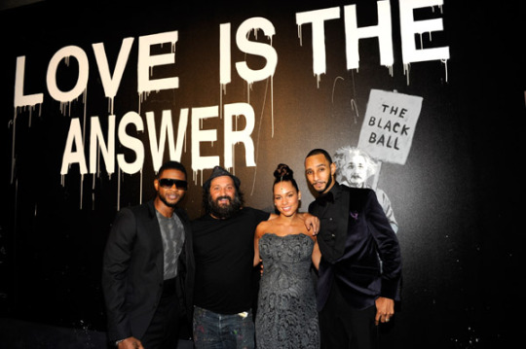News
09/30/2010

Keep A Child Alive Charity with Alicia Keys
JTNDY2VudGVyJTNFJTNDcCUyMGNsYXNzJTNEJTIyYmxvZy10YWclMjIlM0VDaGFyaXR5JTNDJTJGcCUzRSUzQyUyRmNlbnRlciUzRQ== Keep A Child Alive Charity with Alicia Keys September…
BrainWash
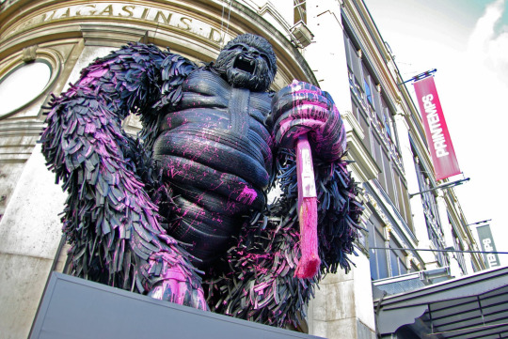News
09/28/2010

“Printemps Loves NY” Collaboration
JTNDY2VudGVyJTNFJTNDcCUyMGNsYXNzJTNEJTIyYmxvZy10YWclMjIlM0VDb2xsYWJvcmF0aW9uJTNDJTJGcCUzRSUzQyUyRmNlbnRlciUzRQ== “Printemps Loves NY” Collaboration September 28, 2010 Printemps, a…
BrainWash
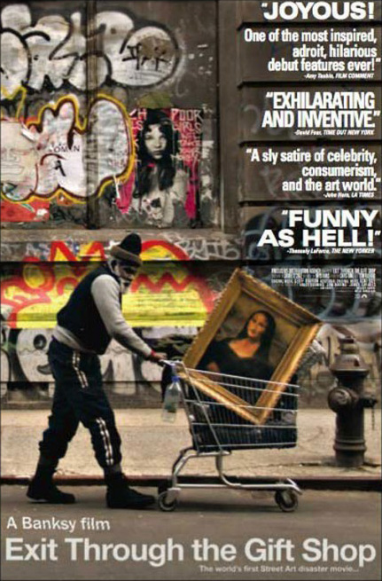News
04/16/2010

Exit Through the Gift Shop (USA Release)
JTNDY2VudGVyJTNFJTNDcCUyMGNsYXNzJTNEJTIyYmxvZy10YWclMjIlM0VQcmVtaWVyJTNDJTJGcCUzRSUzQyUyRmNlbnRlciUzRQ== Exit Through the Gift Shop (USA Release) April 16,…
BrainWash
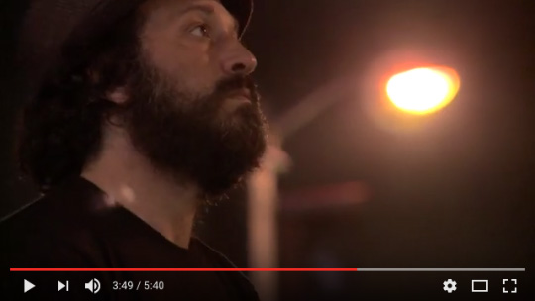News
04/15/2010

Video Feature for the Los Angeles Times
JTNDY2VudGVyJTNFJTNDcCUyMGNsYXNzJTNEJTIyYmxvZy10YWclMjIlM0VWaWRlbyUzQyUyRnAlM0UlM0MlMkZjZW50ZXIlM0U= Video Feature for the Los Angeles Times April 15,…
BrainWash
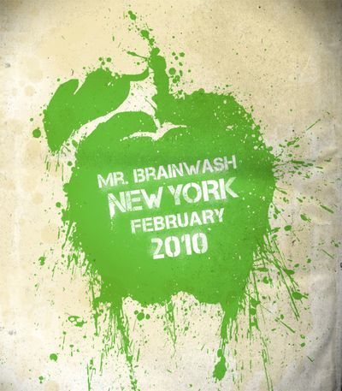News
02/14/2010

“Life Is Beautiful: Icons” NY Solo Exhibit
JTNDY2VudGVyJTNFJTNDcCUyMGNsYXNzJTNEJTIyYmxvZy10YWclMjIlM0VFeGhpYml0JTNDJTJGcCUzRSUzQyUyRmNlbnRlciUzRQ== “Life Is Beautiful: Icons” NY Solo Exhibit February 14,…
BrainWash
News
01/24/2010

Exit Through The Gift Shop, Sundance Film Festival
JTNDY2VudGVyJTNFJTNDcCUyMGNsYXNzJTNEJTIyYmxvZy10YWclMjIlM0VQcmVtaWVyJTNDJTJGcCUzRSUzQyUyRmNlbnRlciUzRQ== Exit Through The Gift Shop, Sundance Film Festival January,…
BrainWash
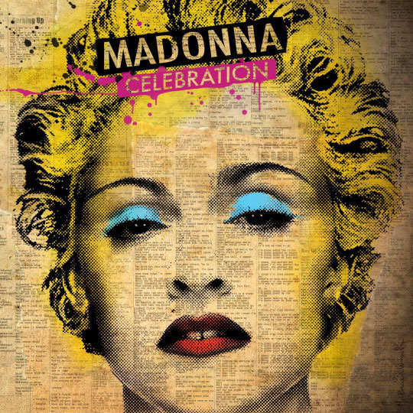News
09/18/2009

Madonna’s “Celebration” Album Cover
JTNDY2VudGVyJTNFJTNDcCUyMGNsYXNzJTNEJTIyYmxvZy10YWclMjIlM0VBbGJ1bSUyMENvdmVyJTNDJTJGcCUzRSUzQyUyRmNlbnRlciUzRQ== Madonna’s “Celebration” Album Cover September 9th, 2009 Madonna, being highly…
BrainWash
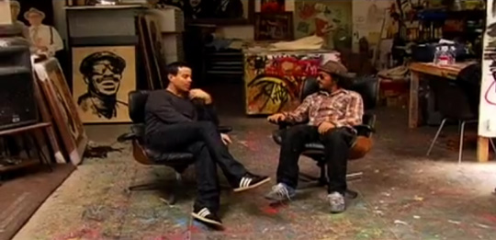News
04/22/2009

The Last Call With Carson Daly
JTNDY2VudGVyJTNFJTNDcCUyMGNsYXNzJTNEJTIyYmxvZy10YWclMjIlM0VJbnRlcnZpZXclM0MlMkZwJTNFJTNDJTJGY2VudGVyJTNF The Last Call With Carson Daly April 22, 2009…
BrainWash
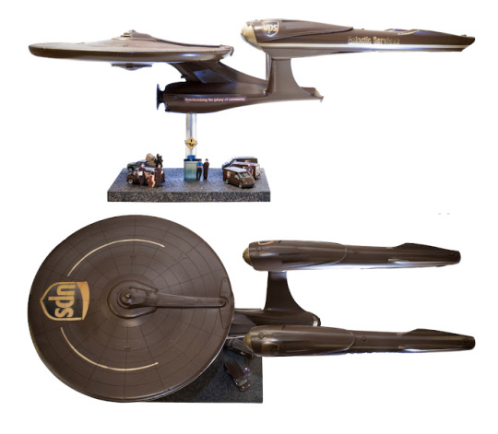News
04/15/2009

Star Trek: The Enterprise Project
JTNDY2VudGVyJTNFJTNDcCUyMGNsYXNzJTNEJTIyYmxvZy10YWclMjIlM0VTaG93JTNDJTJGcCUzRSUzQyUyRmNlbnRlciUzRQ== Star Trek: The Enterprise Project April 15, 2009 Various…
BrainWash
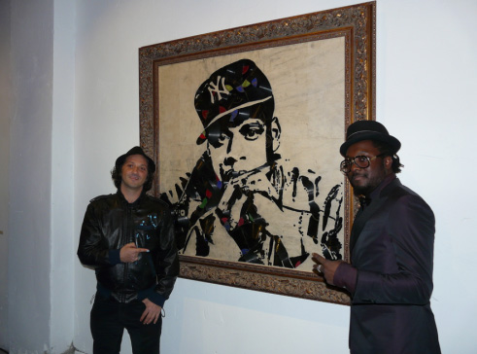News
02/03/2009

Will.I.Am Art Show
Will.I.Am curated an event that incorporated both pop art and…
BrainWash
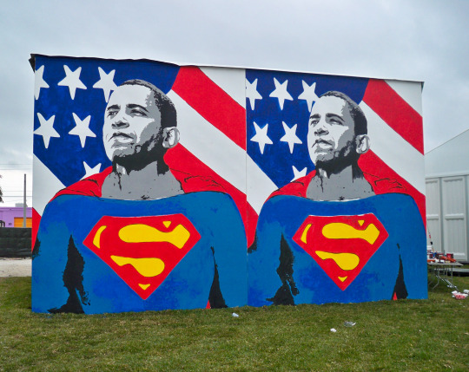News
11/01/2008

Obama Superman
Mr Brainwash took to the streets of Art Basel: Miami…
BrainWash
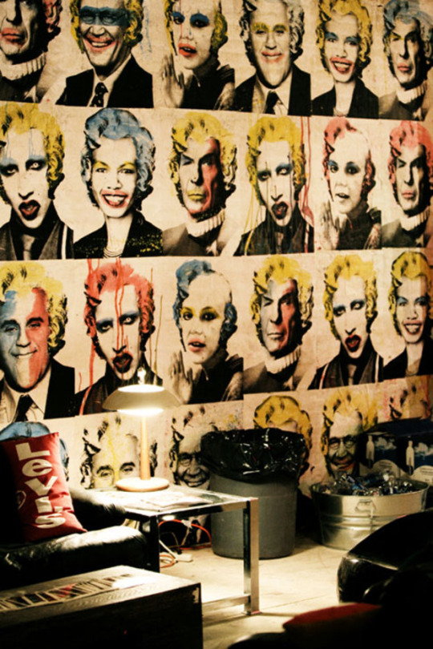News
10/25/2008

Levi’s – FADER Fort, NYC
With not much time on his side, Mr Brainwash assembled…
BrainWash
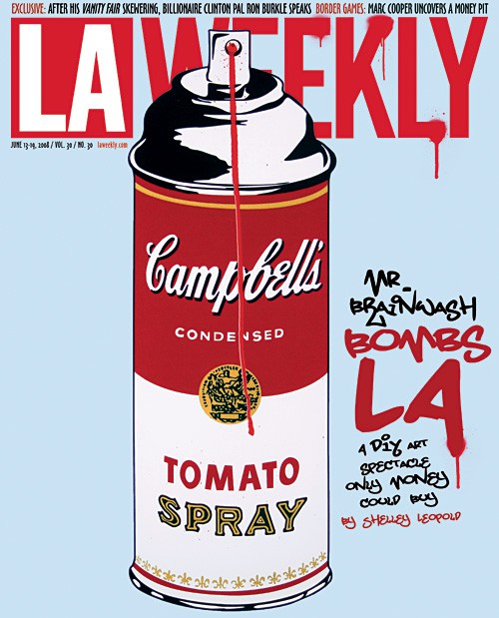News
06/18/2008

“Life Is Beautiful” First Ever Solo Exhibition
The former CBS Columbia Square studios in Hollywood opened its…
BrainWash
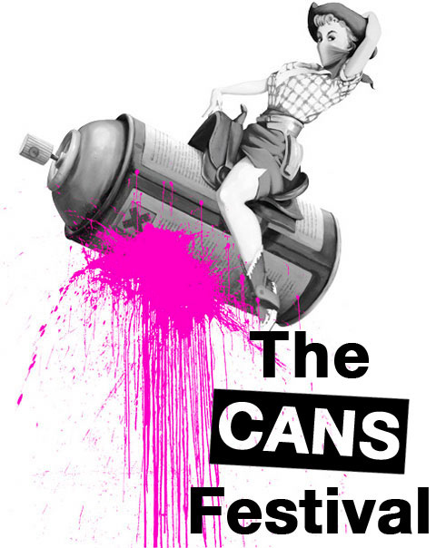News
05/03/2008

The Cans Festival
The Cans Festival was the first British exhibit Banksy coordinated…
BrainWash

