Naples Museum Celebrates Street Art
Date | 2019-12-23 11:00:41
Exhibition

The (post) street art on display at
the Pan Museum in Naples
Nov 22, 2019
The PAN of Naples chooses to create the exhibition « Banksy and the (post)
street art » , the collective dedicated to the underground artistic movement, which began on December 23 and will end on February 16, 2020. The exhibition will involve not only the works of the famous Banksy , also those of Mr. Brainwash, the Obey and Mr. Savethewall.
The aim of the exhibition is to provide visitors with all the interpretative tools to answer a question that has gripped the art world for years: street art is art in all respects ? And if it is, can street art find a place in museums without losing the deeper meaning of its message? Does street art « die » in galleries and auction houses? And is its paradoxical « death », or rather its conservation, itself a rebirth or a mere commercial operation that would outline the definitive appropriation of the market?
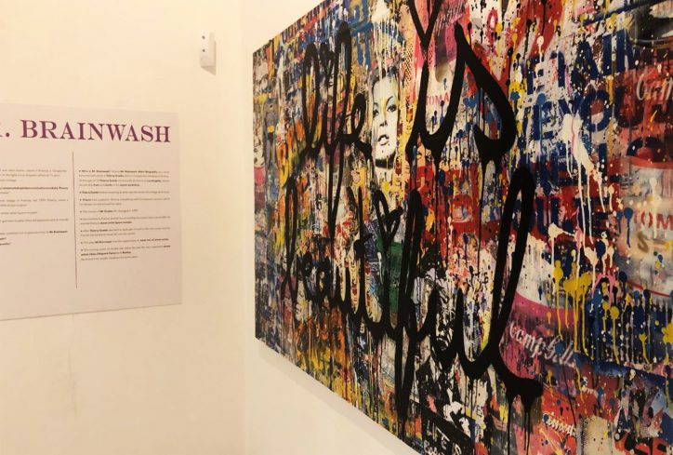
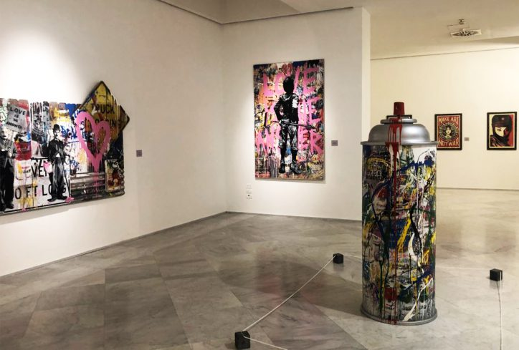
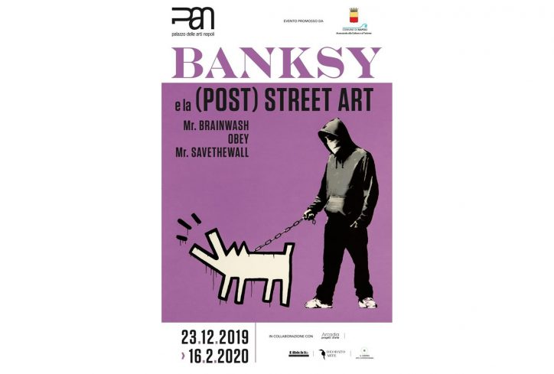
The (post) street art on display at the pan museum in Naples

