Milan is beautiful 2019
Date | 2019-02-12 11:22:08
Project

Mr. Brainwash debuts in Italian solo exhibition
April 4th , 2019
For his first major Italian debut, Mr. Brainwash was featured in Deodato Gallery in Milan for a spring exhibition. Upon arriving in Italy, he conducted interviews, starred as a guest on Italian chef Allessandro Borghese’s cooking show, and celebrated with Italian singer Fedez. The solo show garnered attention across the city and lines stretched around the block to see the collection of his newest artworks.
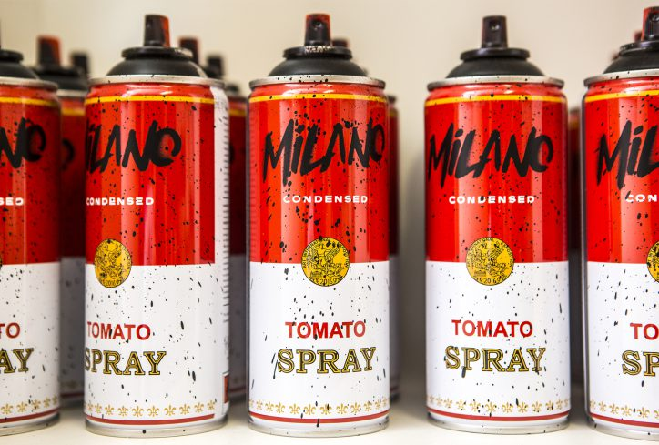
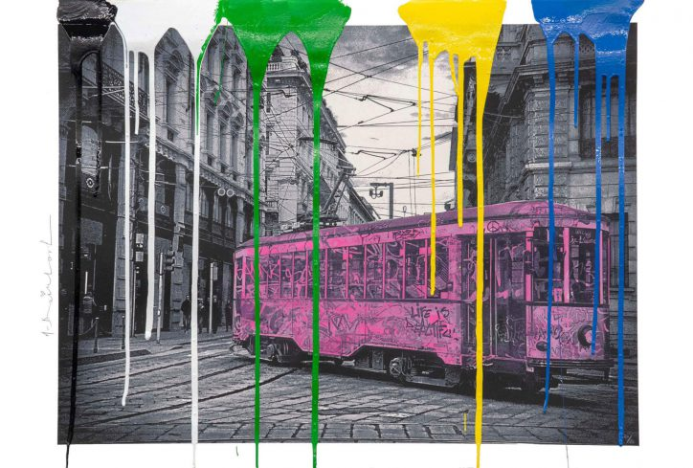
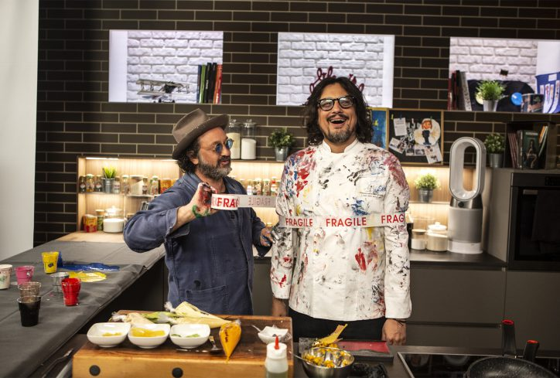
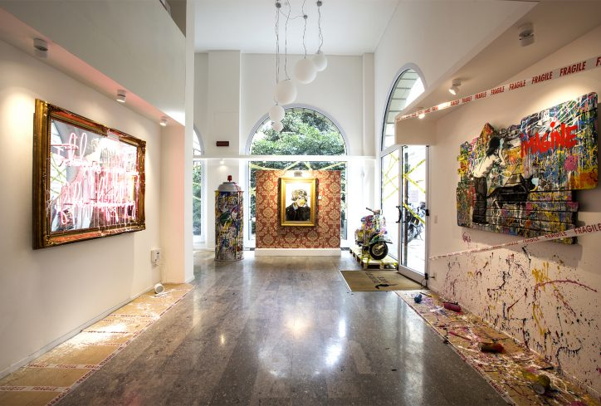
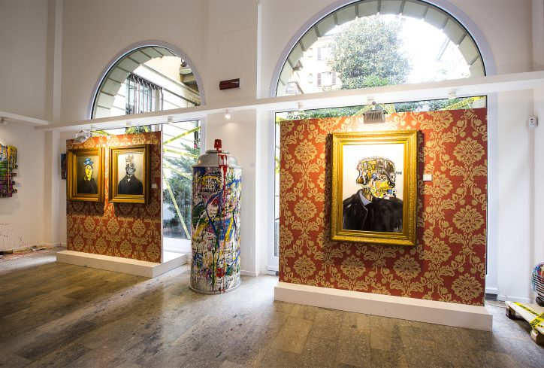
Milan is beautiful

