Marilyn Pop-Folio
Date | 2022-05-27 13:35:36

SOLD OUT
Happy Birthday! In celebration of the late, world-renowned pop icon – Marilyn Monroe, we are pleased to announce the latest edition print by Mr. Brainwash. Monroe POPfolio consists of three design variations; available in two sizes; on Archival Paper and Framed Canvas. The Monroe POPFolio is part of a larger collection to be released in the future.
SOLD OUT
Happy Birthday! In celebration of the late, world-renowned pop icon – Marilyn Monroe, we are pleased to announce the latest edition print by Mr. Brainwash. Monroe POPfolio consists of three design variations; available in two sizes; on Archival Paper and Framed Canvas. The Monroe POPFolio is part of a larger collection to be released in the future.

ARCHIVAL PAPER

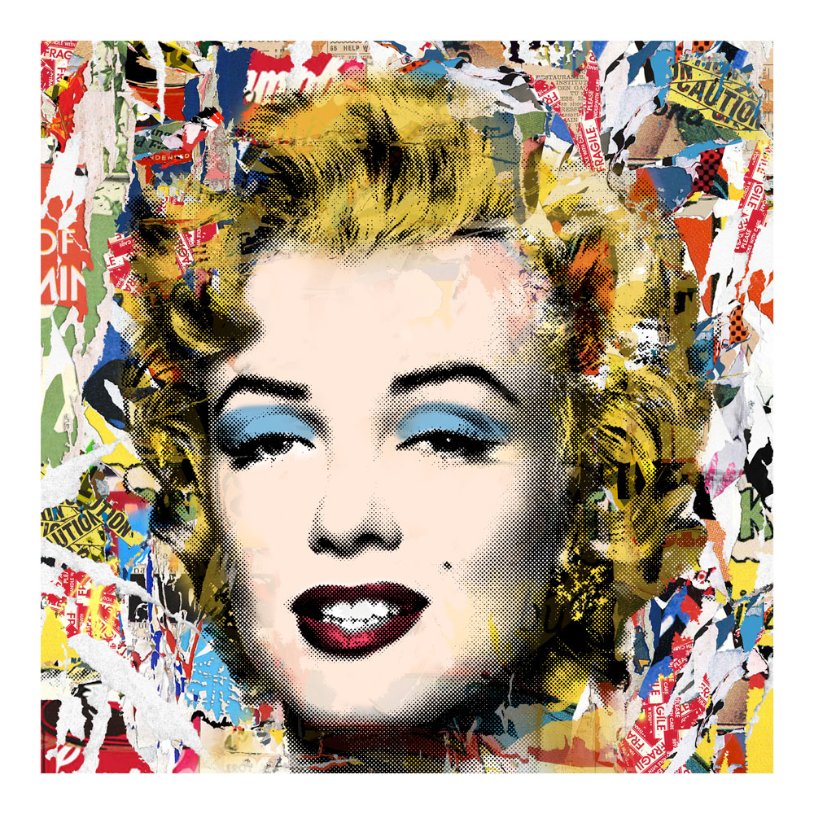
Monroe POPfolio
Archival Paper - Collage
24x24in - Edition of 75 + 7 AP ($1,250 / $1,875)
40x40in – Edition of 25 + 3 AP ($3,500 / $5,250)
Straight Edges
13 Color ScreenPrint
Signed and thumb-printed by the Artist
Certificate of Authenticity
SOLD OUT

Monroe POPfolio
Archival Paper - Fragile
24x24in - Edition of 75 + 7 AP ($1,250 / $1,875)
40x40in – Edition of 25 + 3 AP ($3,500 / $5,250)
Straight Edges
11 Color ScreenPrint
Signed and thumb-printed by the Artist
Certificate of Authenticity
SOLD OUT
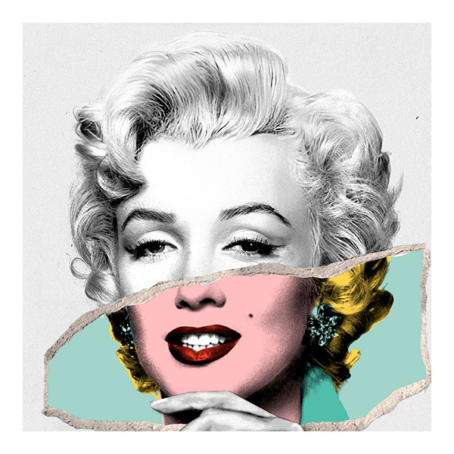
Monroe POPfolio
Archival Paper - Photo Tear
24x24in - Edition of 75 + 7 AP ($1,250 / $1,875)
40x40in – Edition of 25 + 3 AP ($3,500 / $5,250)
Straight Edges
11 Color ScreenPrint
Signed and thumb-printed by the Artist
Certificate of Authenticity
SOLD OUT

CANVAS

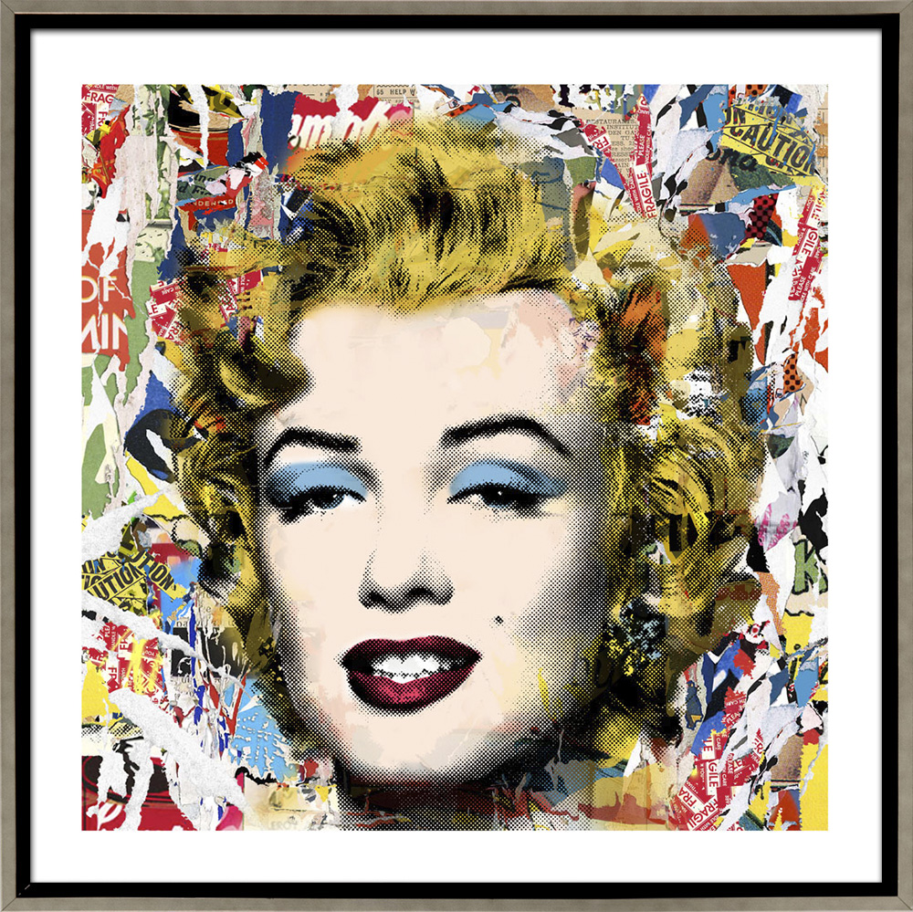
Monroe POPfolio
Framed Canvas - Collage
24x24in - Edition of 3 ($5,000)
40x40in – Edition of 3 ($9,500)
Silver Frame
13 Color ScreenPrint
Signed and thumb-printed by the Artist
Certificate of Authenticity
SOLD OUT
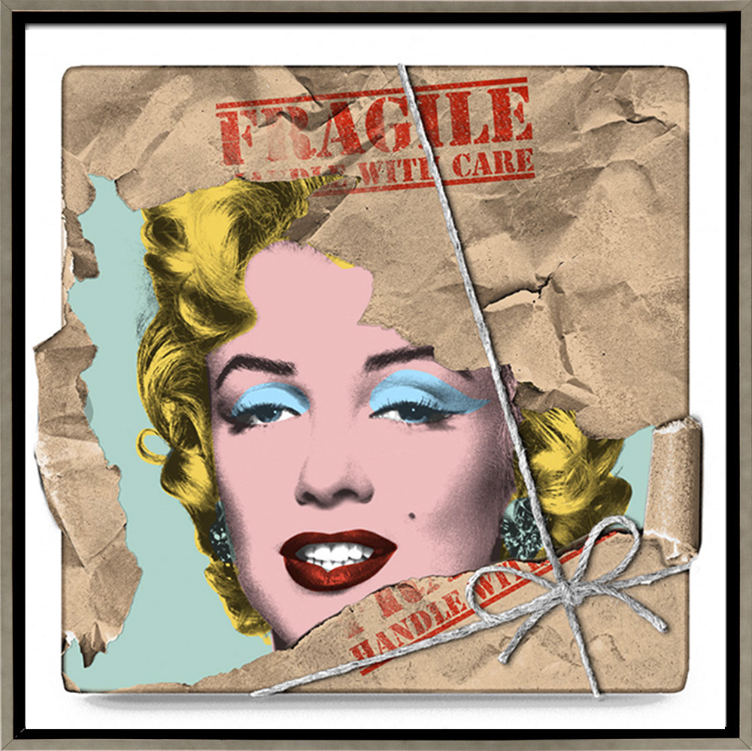
Monroe POPfolio
Framed Canvas - Fragile
24x24in - Edition of 3 ($5,000)
40x40in – Edition of 3 ($9,500)
Silver Frame
11 Color ScreenPrint
Signed and thumb-printed by the Artist
Certificate of Authenticity
SOLD OUT
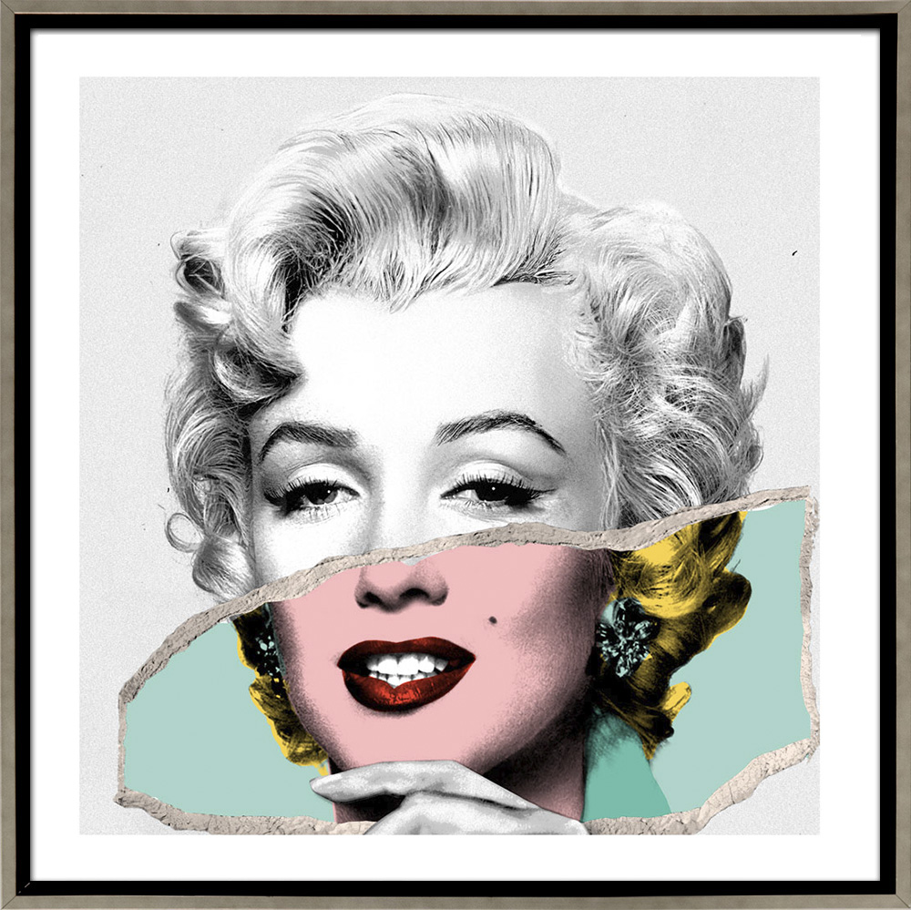
Monroe POPfolio
Framed Canvas - Photo Tear
24x24in - Edition of 3 ($5,000)
40x40in – Edition of 3 ($9,500)
Silver Frame
11 Color ScreenPrint
Signed and thumb-printed by the Artist
Certificate of Authenticity
SOLD OUT

