CASSOREALISM
Date | 2022-10-21 07:29:31

Mr. Brainwash is pleased to announce the launch of a new, 12-Color Silkscreen Edition Print, celebrating 141 years of the birth of an artist that changed the industry forever.
Why? This influential artist decided classic art was boring and started to play and explore; pushing boundaries and changing forms as we know them. Thanks to this artist, modern art was born, giving way to the evolution of contemporary art.
Cassorealism is a 12-Color Screenprint; available as an Archival Paper Edition of 141, and Framed Canvas Edition of 3. Each artwork is signed and thumb-printed by the artist, with a Certificate of Authenticity included.
Mr. Brainwash is pleased to announce the launch of a new, 12-Color Silkscreen Edition Print, celebrating 141 years of the birth of an artist that changed the industry forever.
Why? This influential artist decided classic art was boring and started to play and explore; pushing boundaries and changing forms as we know them. Thanks to this artist, modern art was born, giving way to the evolution of contemporary art.
Cassorealism is a 12-Color Screenprint; available as an Archival Paper Edition of 141, and Framed Canvas Edition of 3. Each artwork is signed and thumb-printed by the artist, with a Certificate of Authenticity included.

ARCHIVAL PAPER

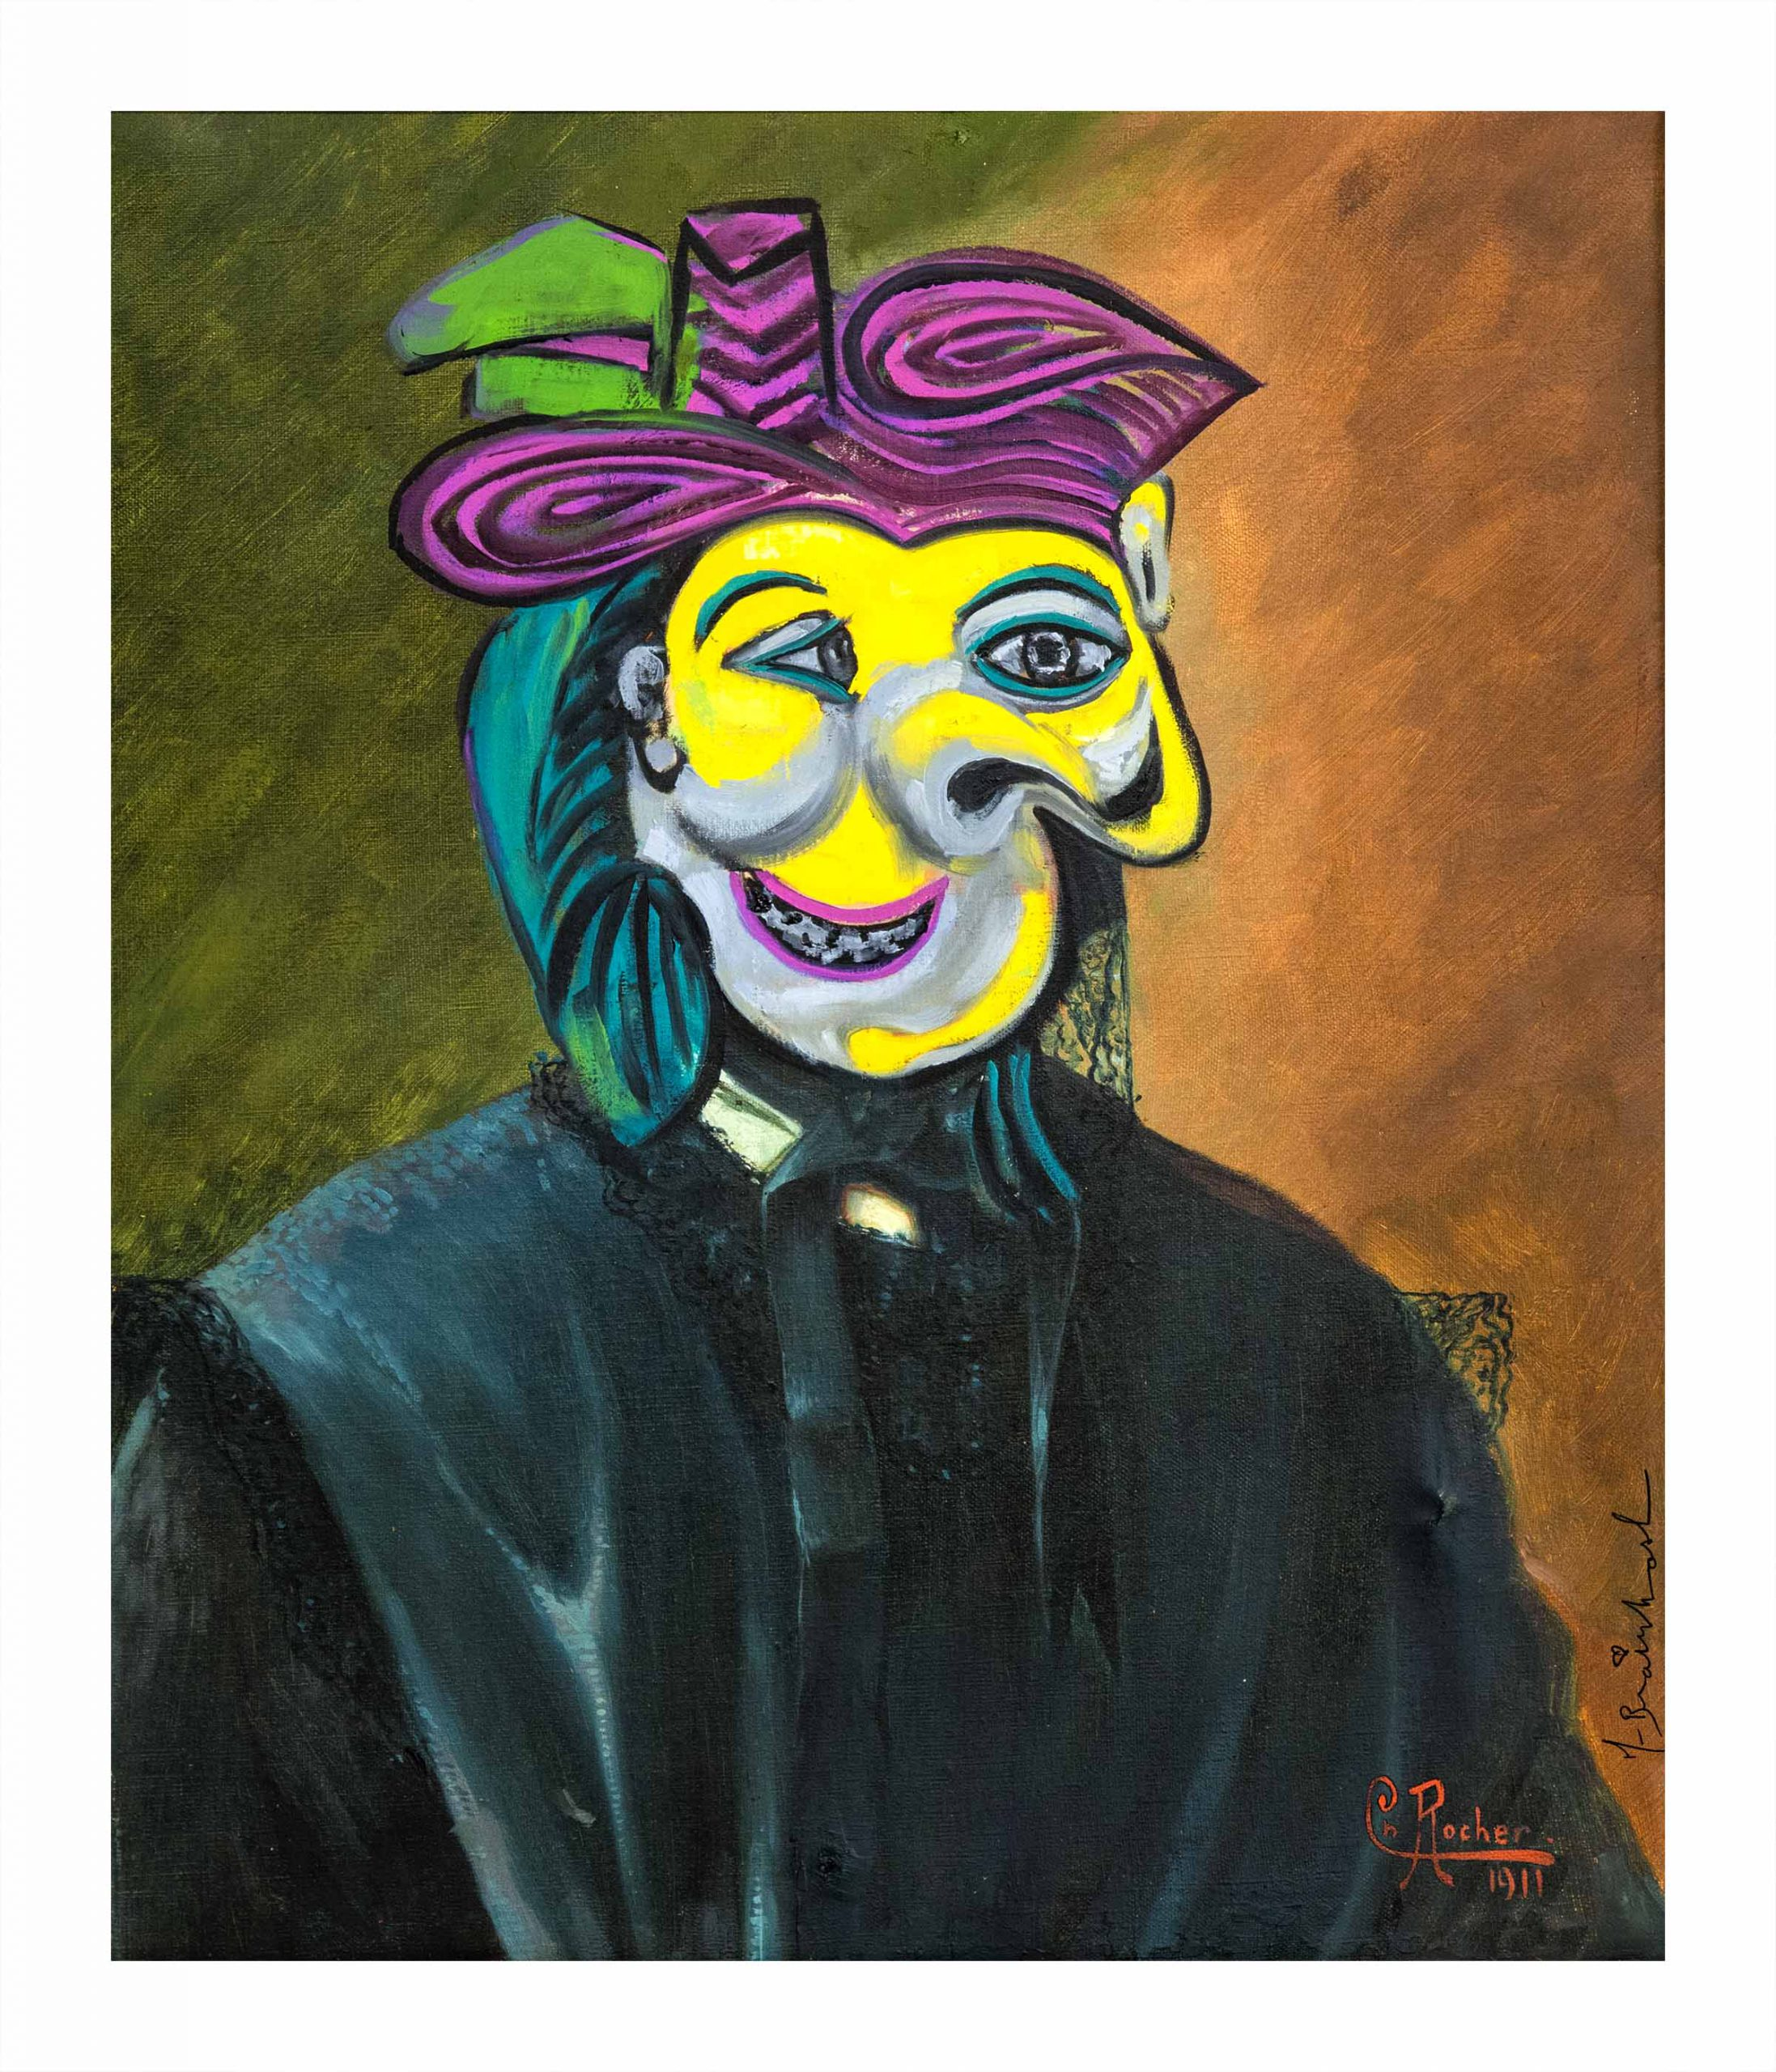
CASSURREALISM
Archival Paper
30in. x 22in.
Edition of 75 + 7 AP
Deckled Edges
12-Color Screenprint
Signed and thumb-printed by the Artist
Certificate of Authenticity
$1,250 / $1,875 (AP)
PURCHASE
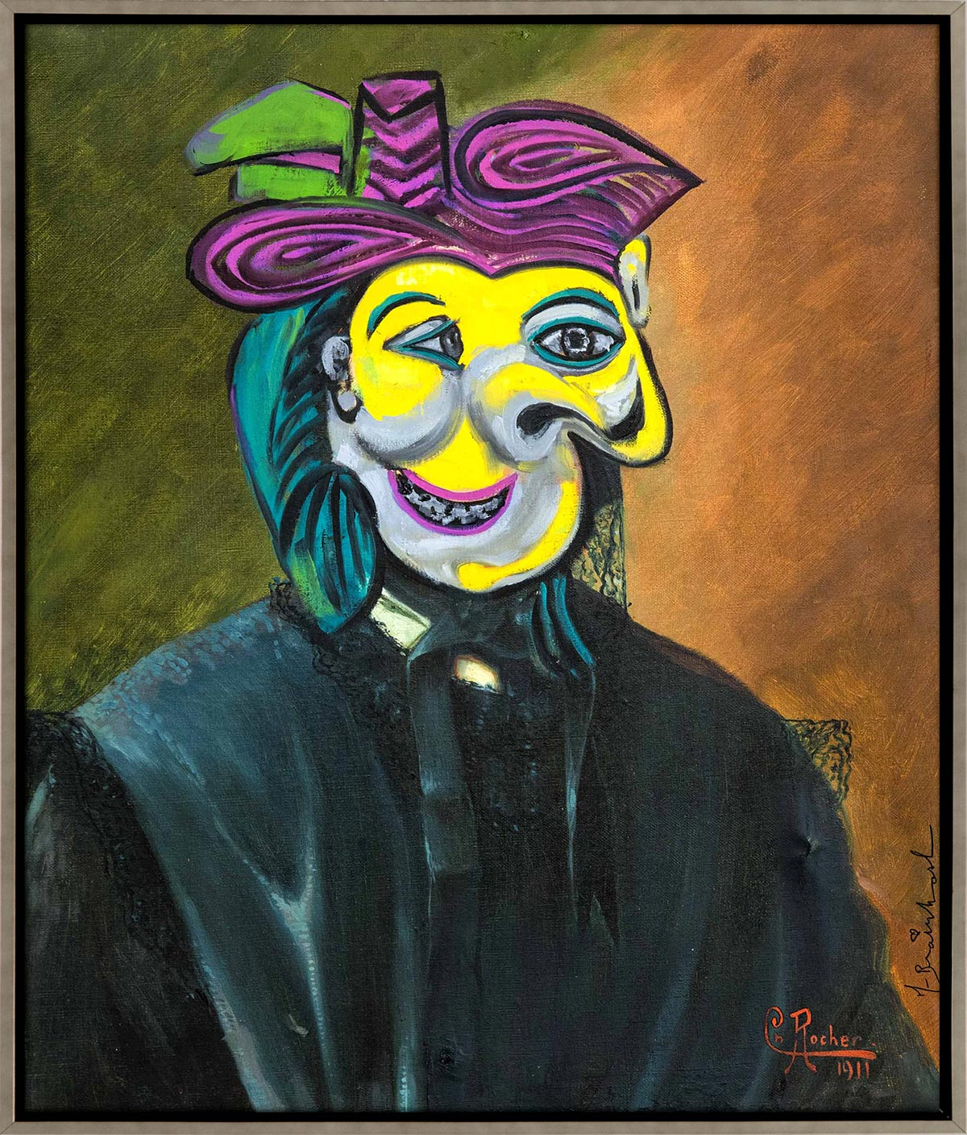
CASSURREALISM
Framed Canvas
30in. x 22in.
Edition of 3
12-Color Screenprint
Signed and thumb-printed by the Artist
Certificate of Authenticity
$5,250
PURCHASE

