CamoSplash
Date | 2022-08-03 11:30:30

SOLD OUT
Many years ago an icon was born. Today we celebrate the father of Pop art and his eternal influence on art as we know it. We are pleased to announce the latest edition print by Mr. Brainwash CamoSplash. The series consists of four designs; with 2 colors variations, available on Archival Paper and Framed Canvas.
Each print is signed and thumb-printed by the Artist and includes a certificate of authenticity.
SOLD OUT
Many years ago an icon was born. Today we celebrate the father of Pop art and his eternal influence on art as we know it. We are pleased to announce the latest edition print by Mr. Brainwash CamoSplash. The series consists of four designs; with 2 colors variations, available on Archival Paper and Framed Canvas.
Each print is signed and thumb-printed by the Artist and includes a certificate of authenticity.

ARCHIVAL PAPER

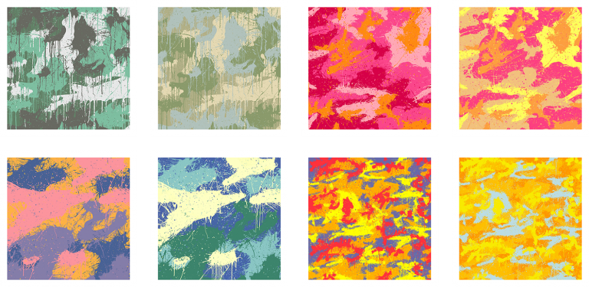
CamoSplash SET
Archival Paper
38in. x 38in.
Straight Edges
4-Color Screenprint
Signed and thumb-printed by the Artist
Certificate of Authenticity
SOLD OUT

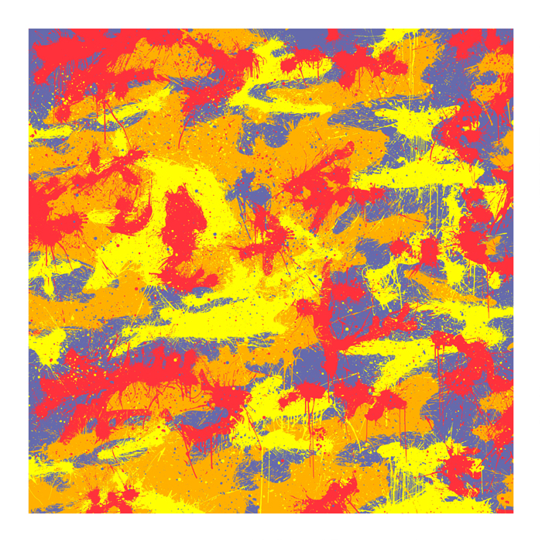
CamoSplash A
38in. x 38in.
Edition of 50 + 5 AP
Straight Edges
4-Color Screenprint
Signed and thumb-printed by the Artist
Certificate of Authenticity
$1,800 / $3,600(AP)
SOLD OUT
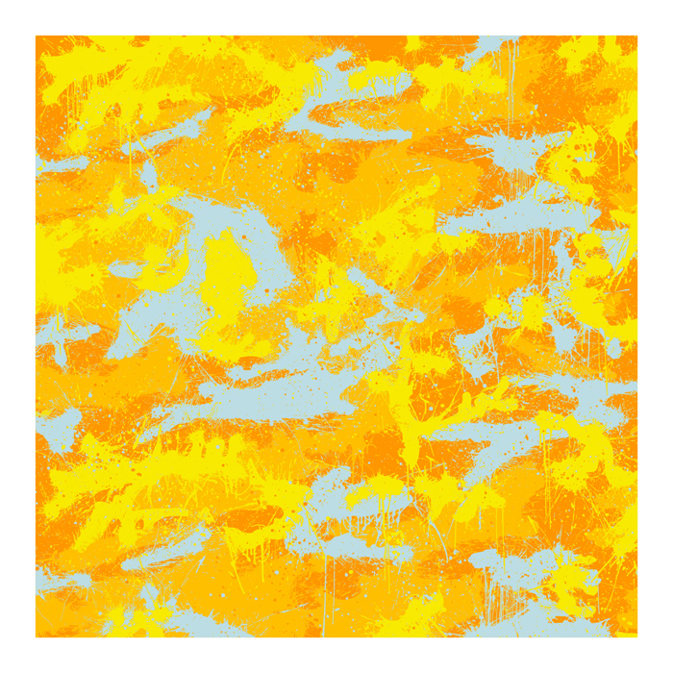
CamoSplash B
38in. x 38in.
Edition of 50 + 5 AP
Straight Edges
4-Color Screenprint
Signed and thumb-printed by the Artist
Certificate of Authenticity
$1,800 / $3,600(AP)
SOLD OUT
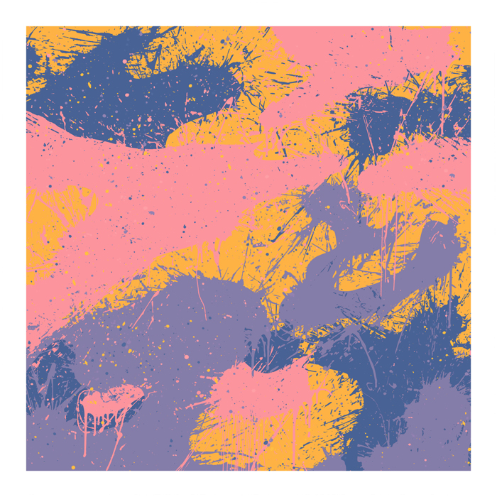
CamoSplash C
38in. x 38in.
Edition of 50 + 5 AP
Straight Edges
4-Color Screenprint
Signed and thumb-printed by the Artist
Certificate of Authenticity
$1,800 / $3,600(AP)
SOLD OUT
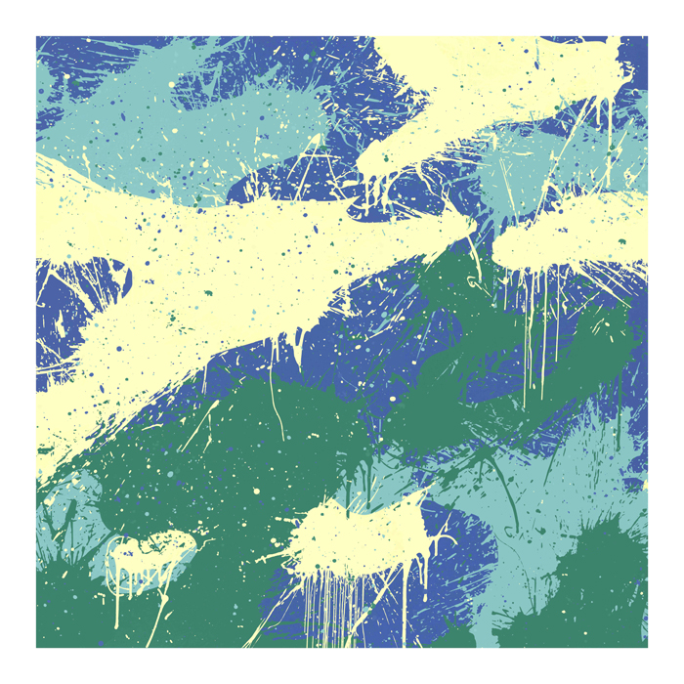
CamoSplash D
38in. x 38in.
Edition of 50 + 5 AP
Straight Edges
4-Color Screenprint
Signed and thumb-printed by the Artist
Certificate of Authenticity
$1,800 / $3,600(AP)
SOLD OUT

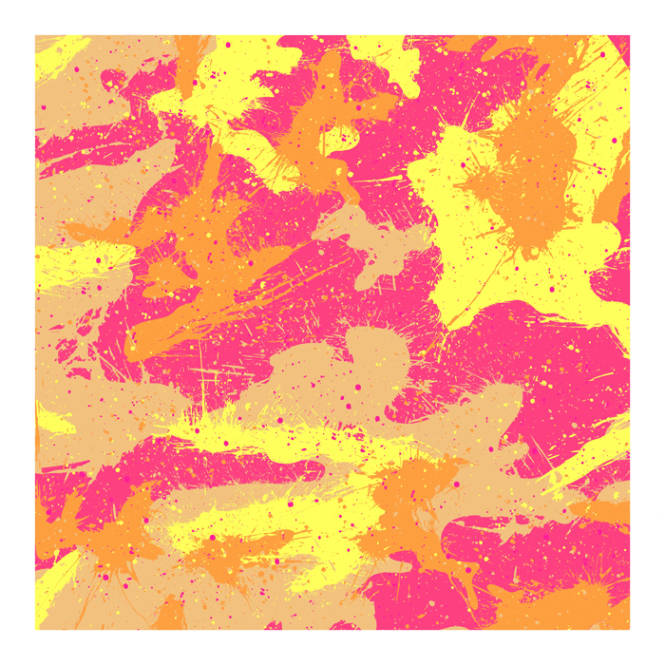
CamoSplash E
38in. x 38in.
Edition of 50 + 5 AP
Straight Edges
4-Color Screenprint
Signed and thumb-printed by the Artist
Certificate of Authenticity
$1,800 / $3,600(AP)
SOLD OUT
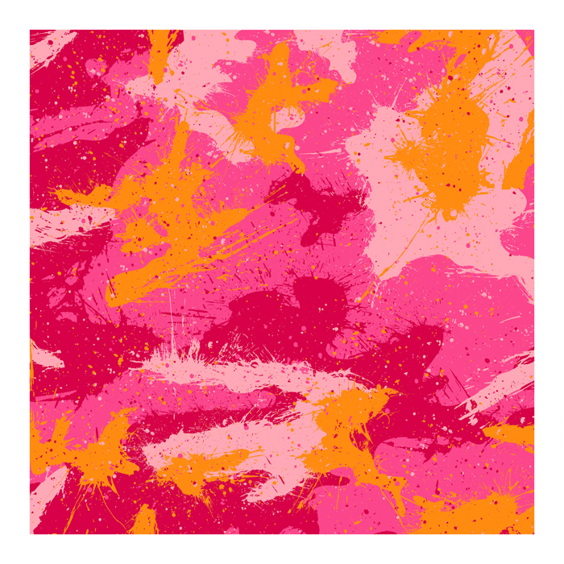
CamoSplash F
38in. x 38in.
Edition of 50 + 5 AP
Straight Edges
4-Color Screenprint
Signed and thumb-printed by the Artist
Certificate of Authenticity
$1,800 / $3,600(AP)
SOLD OUT
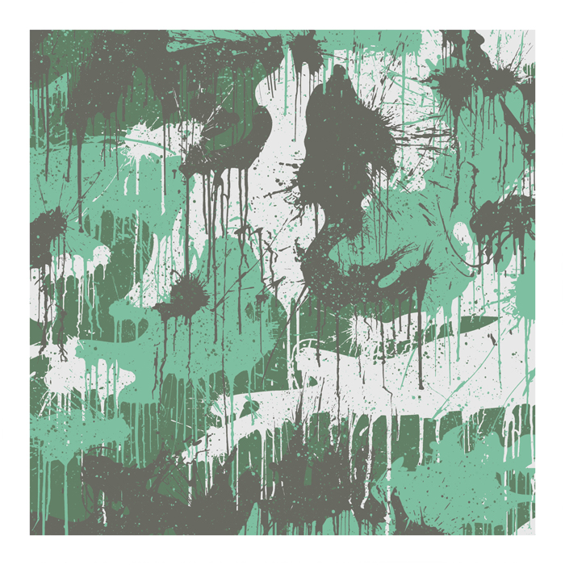
CamoSplash G
38in. x 38in.
Edition of 50 + 5 AP
Straight Edges
4-Color Screenprint
Signed and thumb-printed by the Artist
Certificate of Authenticity
$1,800 / $3,600(AP)
SOLD OUT
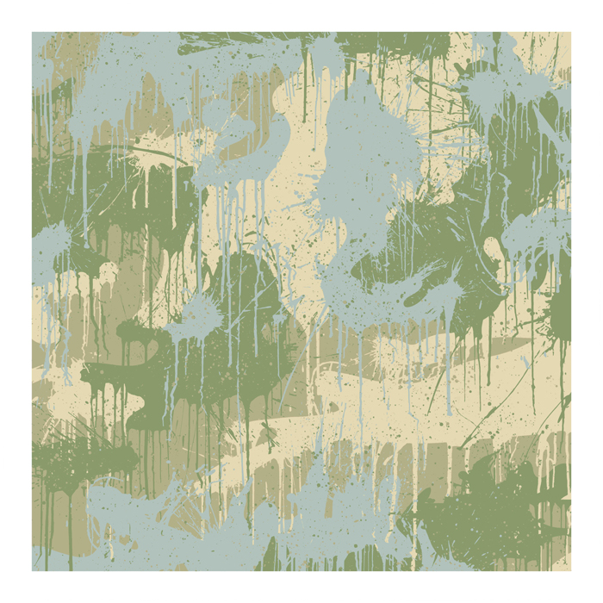
CamoSplash H
38in. x 38in.
Edition of 50 + 5 AP
Straight Edges
4-Color Screenprint
Signed and thumb-printed by the Artist
Certificate of Authenticity
$1,800 / $3,600(AP)
SOLD OUT

CANVAS

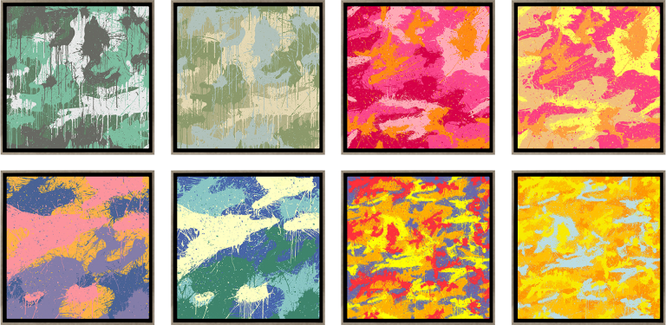
CamoSplash SET
Framed Canvas
38in. x 38in.
Silver Frame
Signed and thumb-printed by the Artist
Certificate of Authenticity
$120,000
SOLD OUT

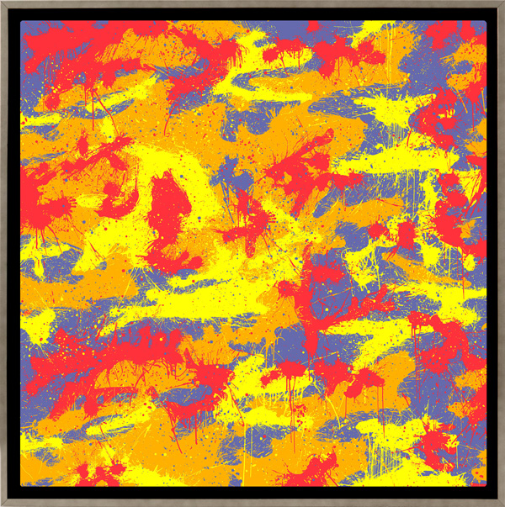
CamoSplash A
Framed Canvas
38in. x 38in.
Edition of 3
Silver Frame
Signed and thumb-printed by the Artist
Certificate of Authenticity
$15,000
SOLD OUT
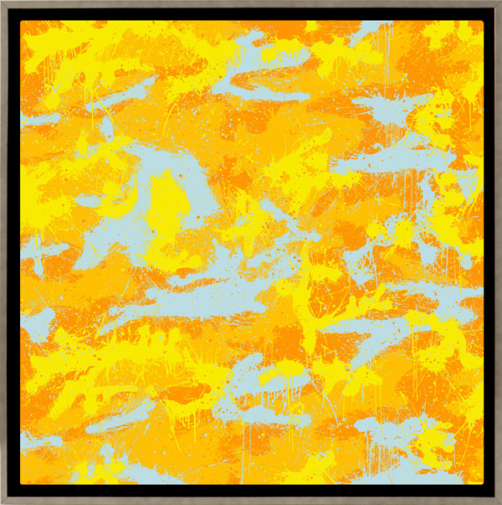
CamoSplash B
Framed Canvas
38in. x 38in.
Edition of 3
Silver Frame
Signed and thumb-printed by the Artist
Certificate of Authenticity
$15,000
SOLD OUT
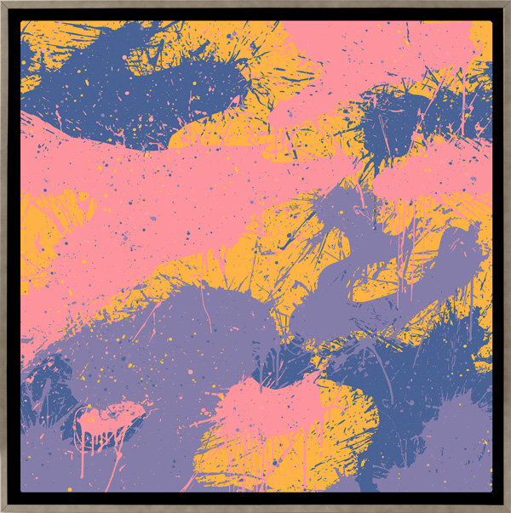
CamoSplash C
Framed Canvas
38in. x 38in.
Edition of 3
Silver Frame
Signed and thumb-printed by the Artist
Certificate of Authenticity
$15,000
SOLD OUT
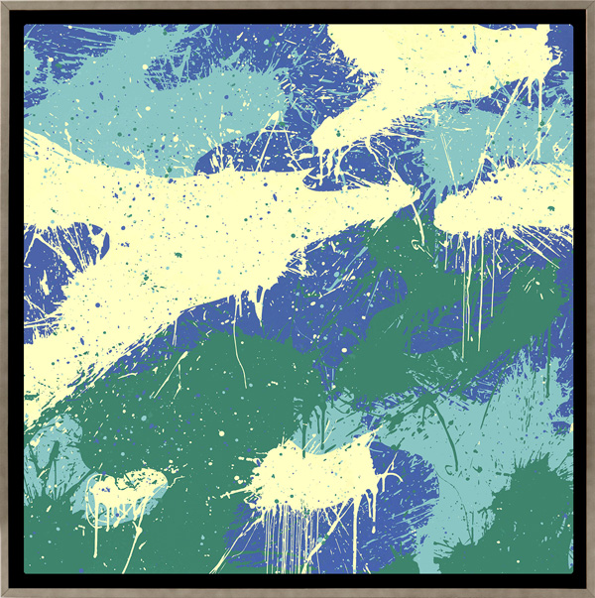
CamoSplash D
Framed Canvas
38in. x 38in.
Edition of 3
Silver Frame
Signed and thumb-printed by the Artist
Certificate of Authenticity
$15,000
SOLD OUT

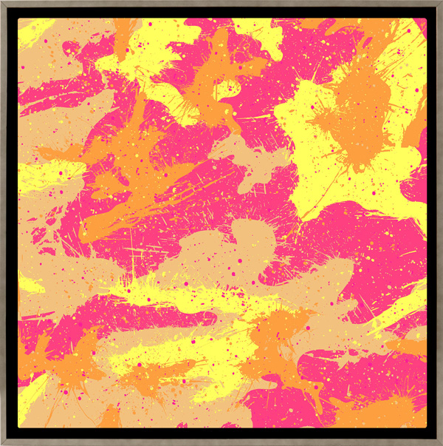
CamoSplash E
Framed Canvas
38in. x 38in.
Edition of 3
Silver Frame
Signed and thumb-printed by the Artist
Certificate of Authenticity
$15,000
SOLD OUT
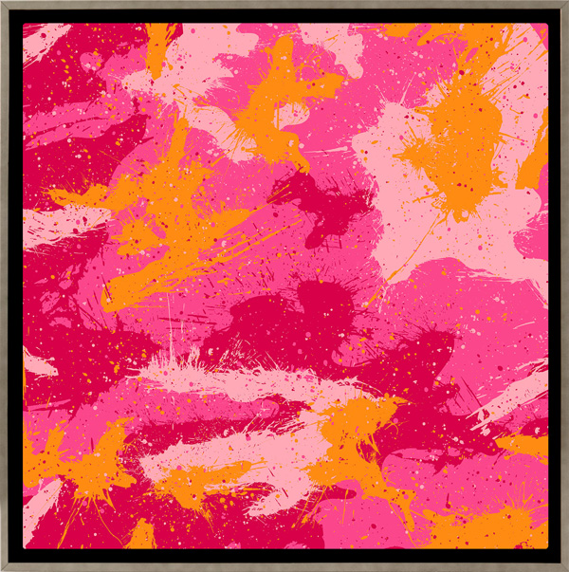
CamoSplash F
Framed Canvas
38in. x 38in.
Edition of 3
Silver Frame
Signed and thumb-printed by the Artist
Certificate of Authenticity
$15,000
SOLD OUT
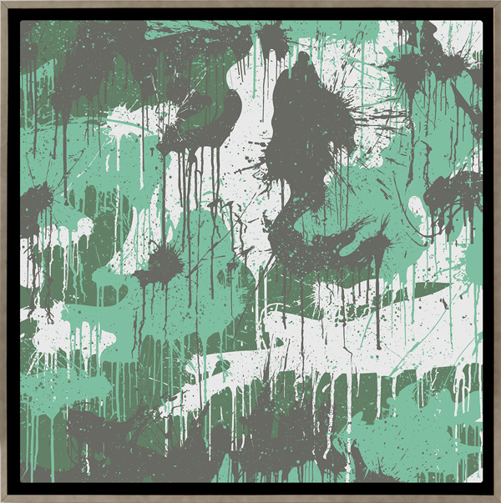
CamoSplash G
Framed Canvas
38in. x 38in.
Edition of 3
Silver Frame
Signed and thumb-printed by the Artist
Certificate of Authenticity
$15,000
SOLD OUT
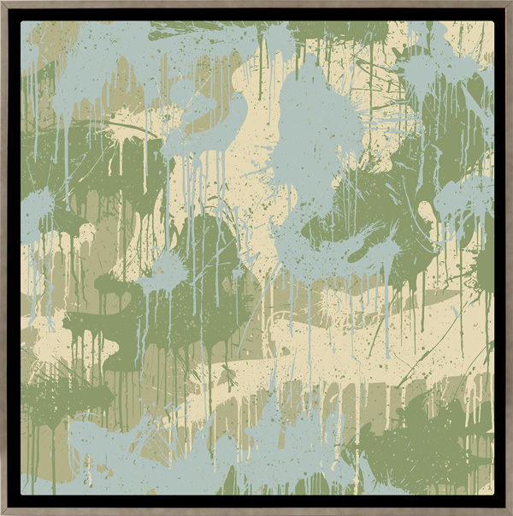
CamoSplash H
Framed Canvas
38in. x 38in.
Edition of 3
Silver Frame
Signed and thumb-printed by the Artist
Certificate of Authenticity
$15,000
SOLD OUT

