Best of L.A. 2020
Date | 2020-07-24 11:33:29
Mural

Best of L.A. 2020
July 21, 2020
Mr. Brainwash has designed two covers for L.A. mag’s 2020 Best of L.A. issue, one of which is now featured on the side of the 1255 S. La Brea Ave building.
The wall art is comprised of the artist’s well-known imagery and iconic L.A. landmarks.
In an interview done by the magazine, Brainwash stated. “We’re not just Los Angeles, we are a family today. We are all together. We all have problems, but we’re all going to resolve it together. We’re going to make it better together.”
LA Magazine
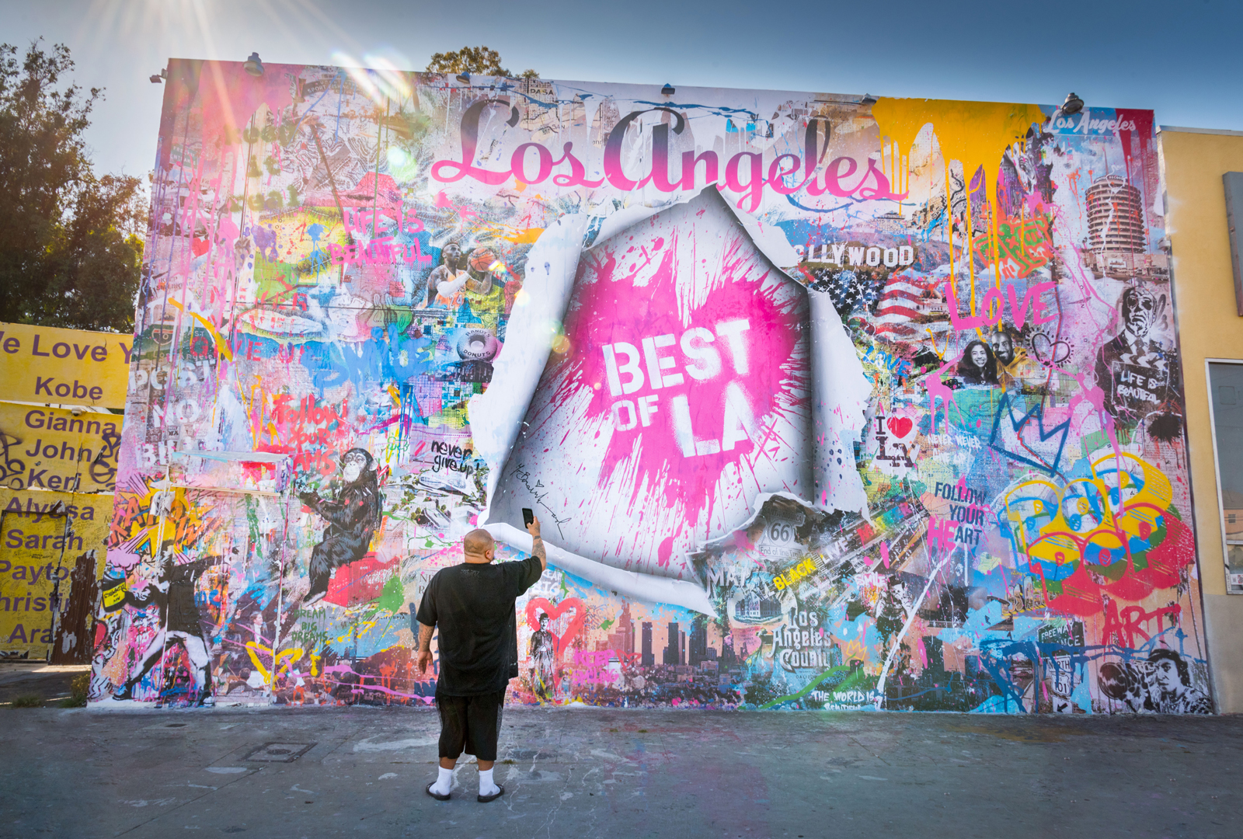
Best of L.A. 2020 / LA Mag

