Art Basel Miami
Date | 2015-12-01 06:00:00
Collaboration

Art Basel - Miami
December 1, 2015
Mr Brainwash returned to Miami Beach for Art Basel, attending Haute Living’s annual Basel party to celebrate his collaboration with the luxury Swiss watch brand and friend Eva Longoria.
Hubolt had invited Mr Brainwash to guest-curate the visual merchandising of its Miami boutique, located in the Miami Design District.
Mr Brainwash presented artwork to Eva Longoria to benefit the Eva Longoria Foundation, an organization founded by the actress to benefit Latinas nationwide through education and entrepreneurship.
Among the artwork presented to Eva Longoria for her foundation, the artist also turned a Hubolt timepiece into art with his signature paint splatters in bright, bold colors.
Click to view
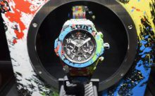
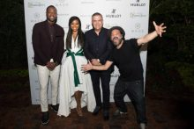
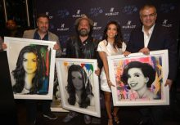
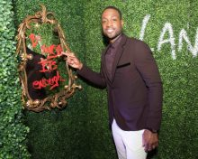
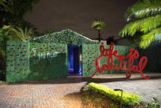

Art Basel - Miami

