Art Basel Hong Kong
Date | 2016-03-21 17:00:00
Collaboration

Art Basel - Hong Kong
March 21, 2016
Art Basel expanded to Hong Kong in 2013 and for its third year, Mr Brainwash attended the event with his own “Life is Beautiful” solo exhibit.
The artist teamed up with Lan Kwai Fong, one of Hong Kong’s biggest lifestyle company with investments in restaurants, bars and real estate, to host a cocktail party that ended with a live-painting performance.
For more information click here

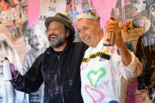
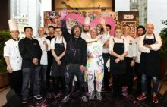
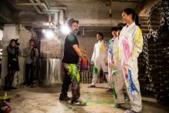
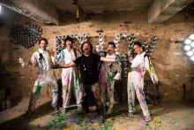
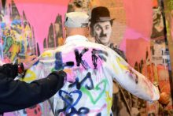

Art Basel - Hong Kong

